
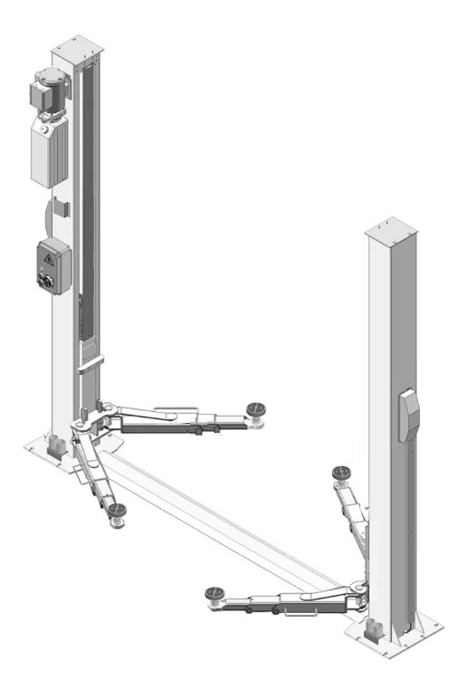
TWO-POST LIFT
Model:A240X

CONTENTS

Product Features and Specifications ............................................1

Installation Requirement ...........................................................3

Steps of Installation………………………………………………………………………………4

Exploded View .........................................................................24

Test Run..................................................................................28

Operation Instruction ...............................................................29

Maintenance ...........................................................................30

Trouble Shooting .....................................................................31

Parts List ................................................................................32

I. PRODUCT FEATURES AND SPECIFICATIONS
FLOORPLATE CHAIN-DRIVE TWO POST LIFT Model A240X (See Fig.1)
· Compact design
· Dual hydraulic cylinders is designed and manufactured according to standard, utilizing imported seals
· Self- lubricating UHMW Polyethylene sliders and bronze bush
· Single-point safety release, and dual safety design
· 2 in 1 lifting arms design, combined drop-in and double screw rubber pad assembly

Fig. 1

SPECIFICATIONS
Model | Style | Lifting Capacity | Lifting Time | Lifting Height | Overall Height | Overall Width | Width  Between Columns | Minimum  Pad Height | Motor
A240X | Floor-plate  Chain-drive | 4.0T  9,000 lbs | 49S | 1950-2085mm  76 7/8”-82 1/8” | 2841mm  111 7/8” | 3460mm  136 1/4” | 2850mm  112 1/4” | 100-235mm  4”-7” | 2.0/3.0HP

Arm Swings View

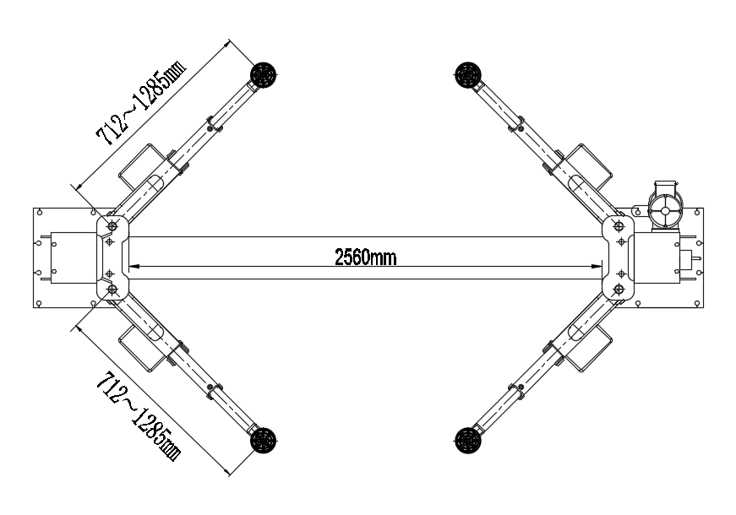

Fig. 2

MODEL A240X SPECIFICATIONS
II. INSTALLATION REQUIREMENT
- TOOLS REQUIRED

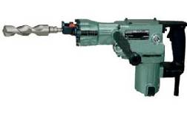
  - Rotary Hammer Drill (Φ19)

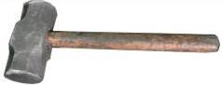
  - Hammer

  - Level Bar
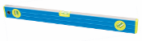

  - English Spanner (12")
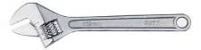

- Wrench set
(10#, 13#, 14#, 15#, 17#, 19#, 24#, 27#)
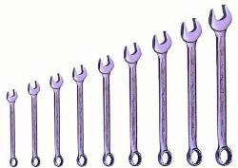

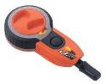
  - Carpenter’s Chalk

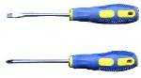
  - Screw Sets

  - Tape Measure (7.5m)
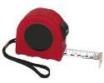

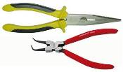
  - Pliers

  - Socket Head Wrench
(4# 5# 6#)
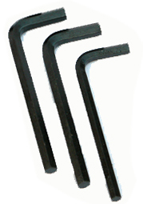

Fig. 3

B. SPECIFICATIONS OF CONCRETE (See Fig. 4)
Specifications of concrete must be adhered to the specification as following.
Failure to do so may result in lift and/or vehicle falling.
1. Concrete must be thickness 100mm minimum and without reinforcing steel bars，and must be dried totally before the installation.
2. Concrete must be in good condition and must be of test strength 3,000psi (210kg/cm²) minimum.
3. Floors must be level and no cracks.
C. POWER SUPPLY
The electrical source must be 2.2Kw minimum. The source cable size must be 2.5mm² and in good condition of contacting with floor.
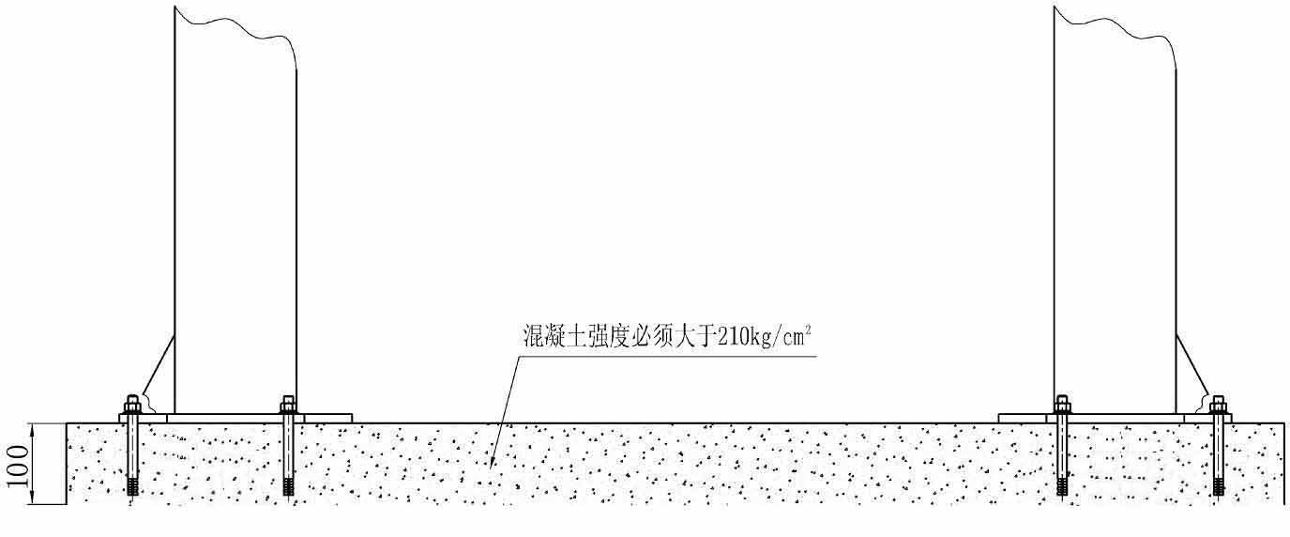

Concrete intensity must be 3000psi (210Kg/cm² ) minimum
95

Fig. 4
III. STEPS OF INSTALLATION
A. Location of Installation
Check and insure the installation location (concrete, layout, space size etc.) is suitable for lift installation.
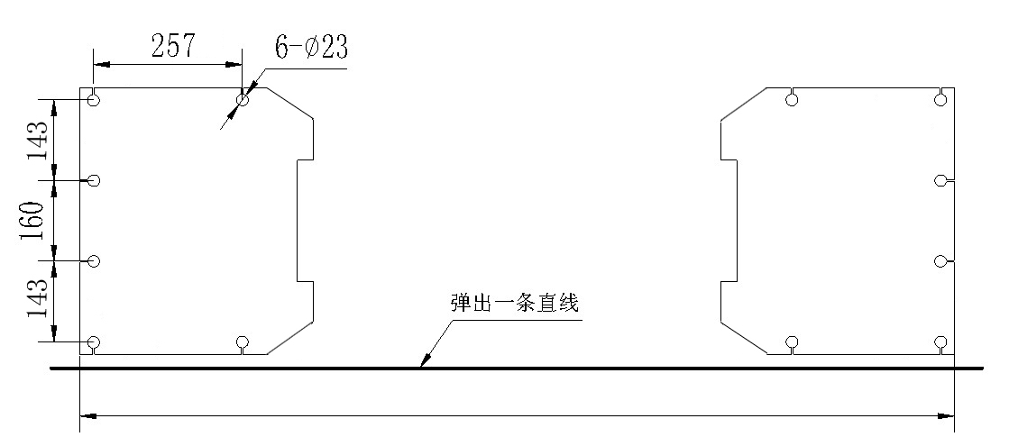
B. Use a carpenter’s chalk line to establish installation layout of baseplate (See Fig. 5).

Chalk line

Fig. 5

C. Check the parts before assembly.
1. Packaged lift and hydraulic power unit (See Fig. 6).
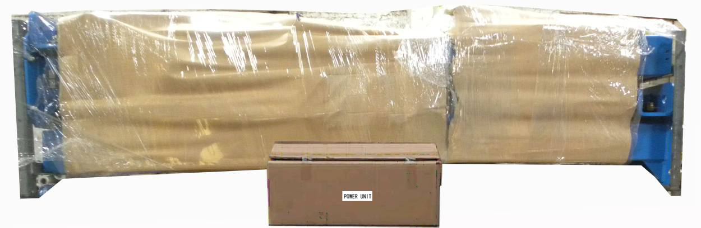

Fig. 6

2. Move the lift aside with fork lift or hoist, and open the outer packing carefully
(See Fig. 7).
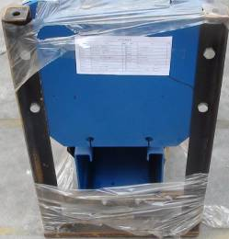
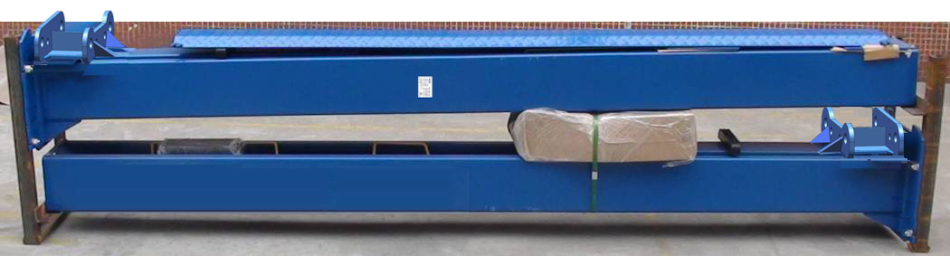

Shipment Parts list
Floor cover
Parts box
Serial nameplate

Fig. 7

3. Take off the parts from upper and inside the column, then take out the parts box (See Fig. 8).
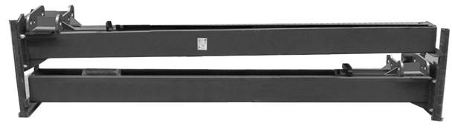

Fig. 8

4. Loosen the bolts of the upper package stand, take off the upper column and remove the package stand.
5. Move aside the parts and check the parts according to the shipment parts list
(See Fig. 9).
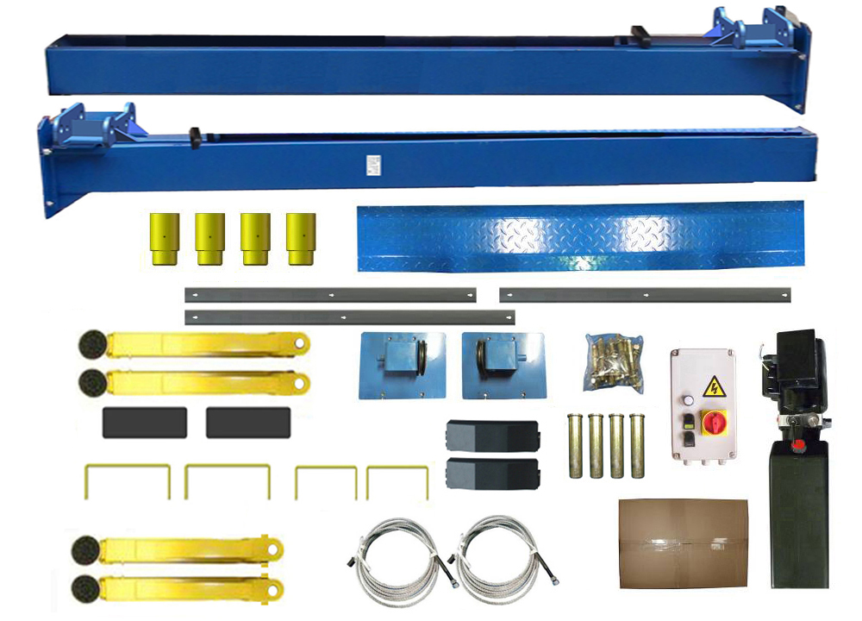

101

Fig. 9

6. Open the carton of parts and check the parts according to parts box list
(See Fig. 10).

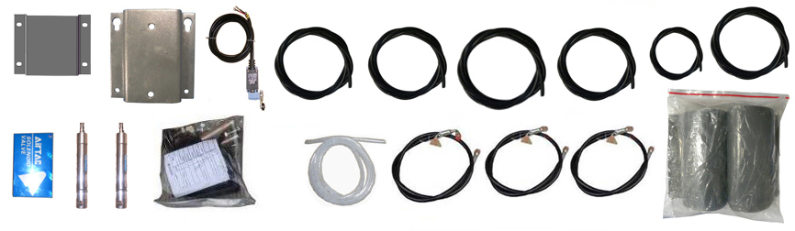

Fig. 10

7. Check the parts of the parts bag according to parts bag list (See Fig. 11).
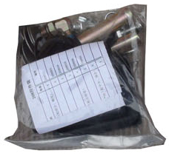
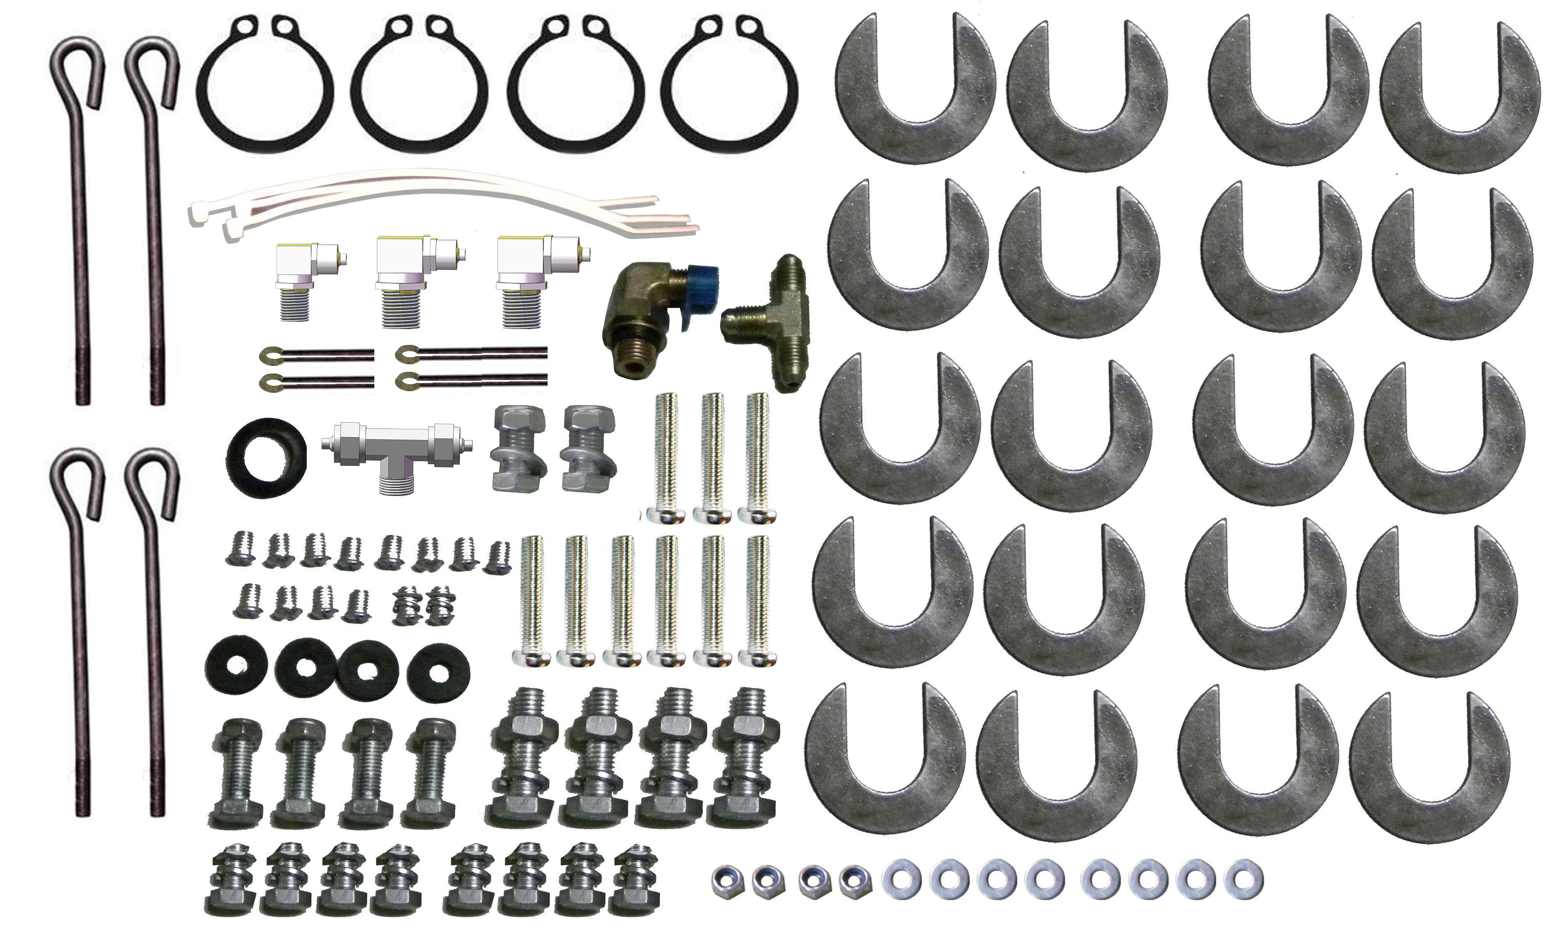

Fig. 11

D. Position powerside columns
Lay down two columns on the installation site parallelly, position the powerside column according to the actual installation site. Usually, it is suggested to install powerside column on the front-right side from which vehicles are driven to the lift
(See Fig. 12).

Powerside column
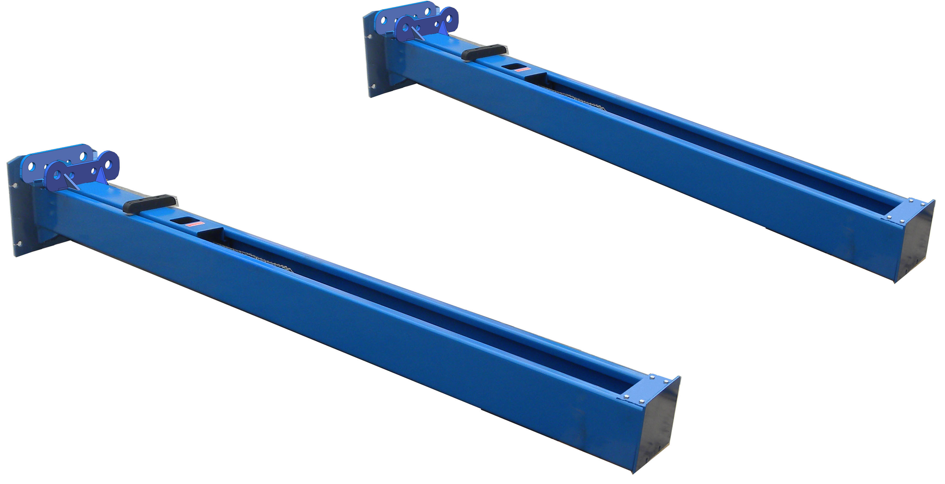
Offside column

Car-in direction

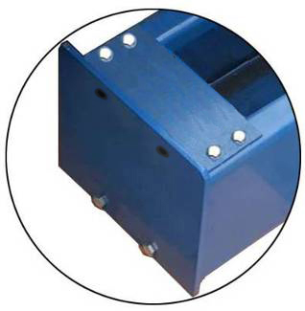

Assemble top plate using M10*35 hex bolt with nut and lock washer

Fig. 12

E. Connecting the cables
1．Connect the cables under step a to f (See Fig. 13).

b. Push the carriages higher than chain pulley, cable pass through the top of the carriages and pass through the hole of the bottom steel plate of the carriages

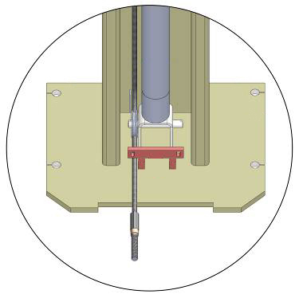
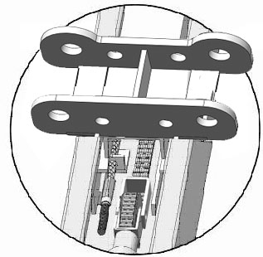

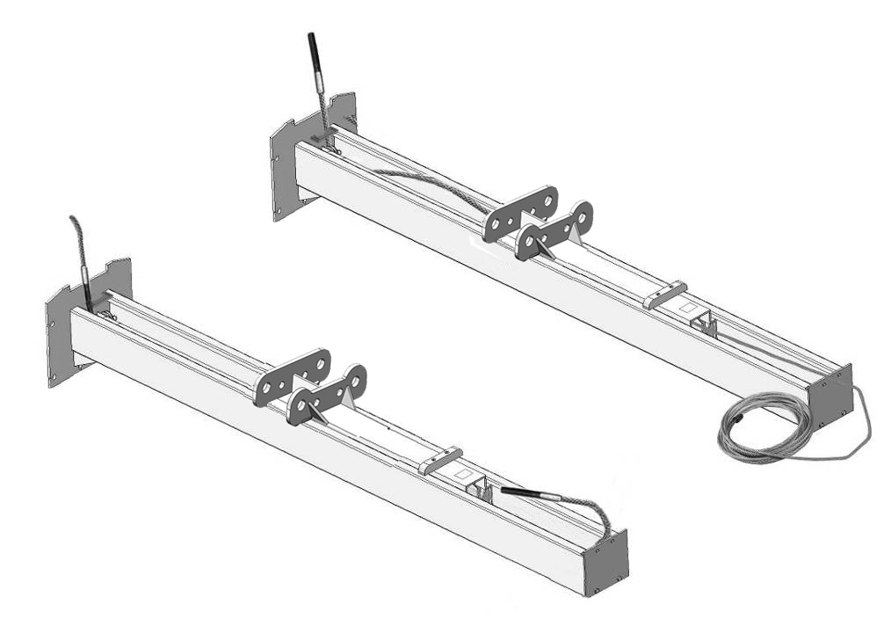

c. Pass through the cable from the small pulley

a. Cable pass through the carriage

d. Cable pas through the small pulley in another column

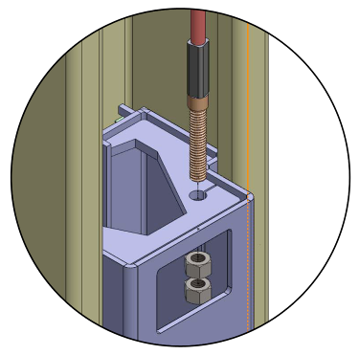

e. Pull the cable from bottom to top and pass through the cable from big pulley
f. The fitting of cable pass through the hole of the carriages and be screwed with two cable nuts

Fig. 13

2．Install cables (See Fig. 14).

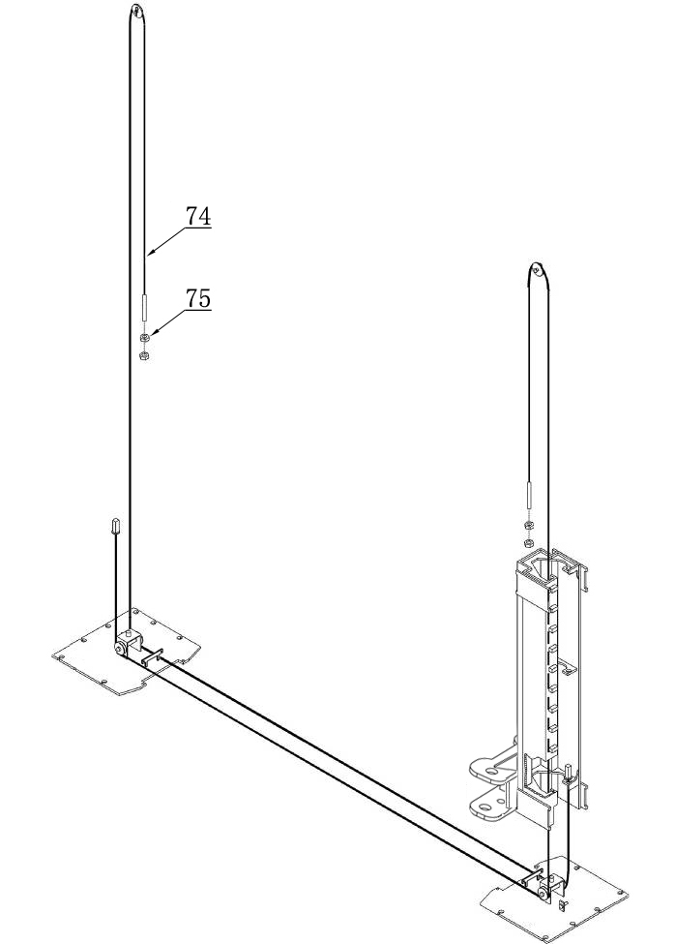
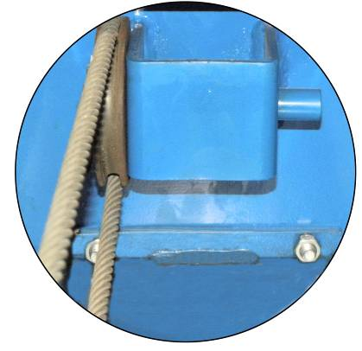
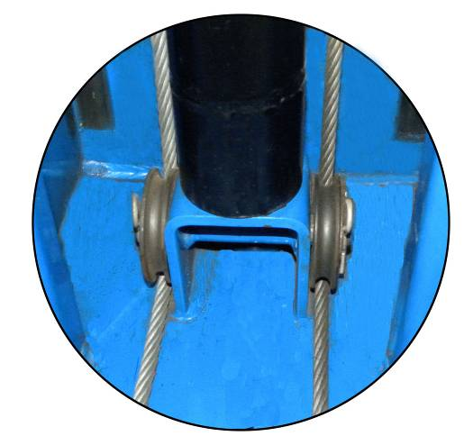

Fig. 14

F. Assembly oil hose assy.
1. Install oil hose (See Fig. 15)
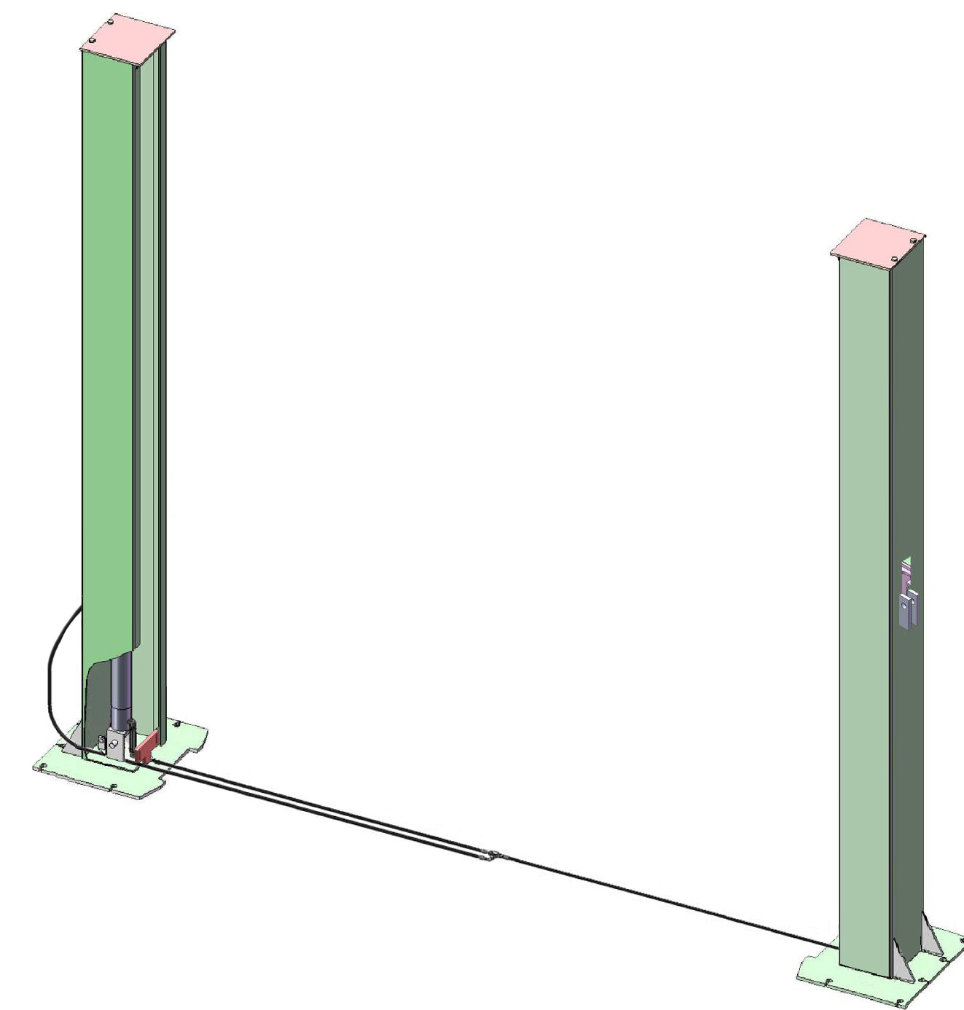
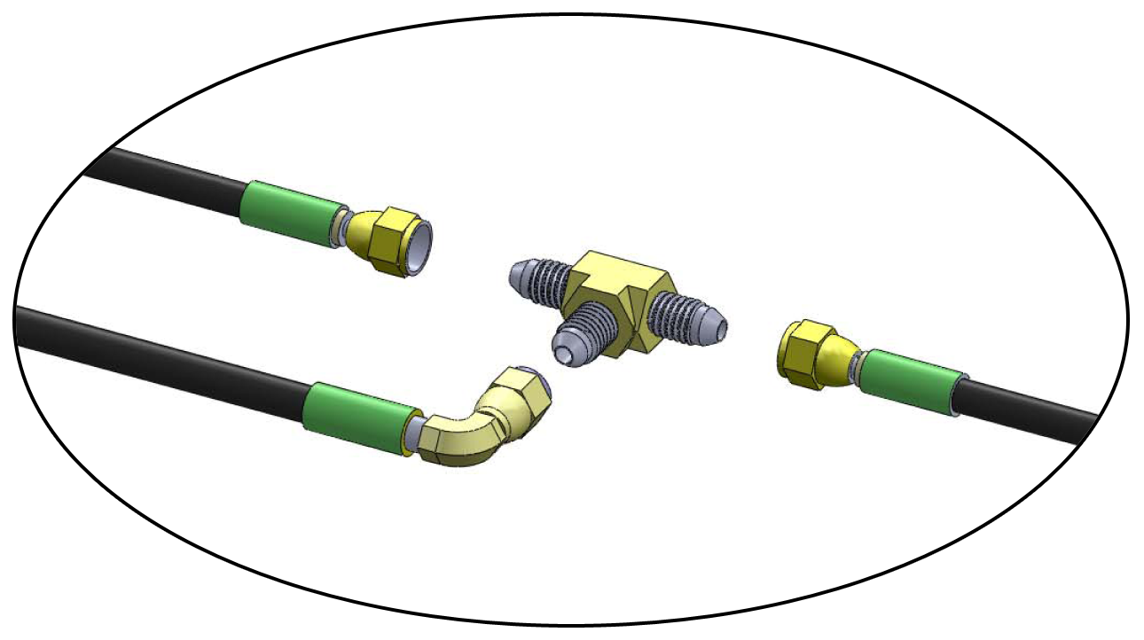
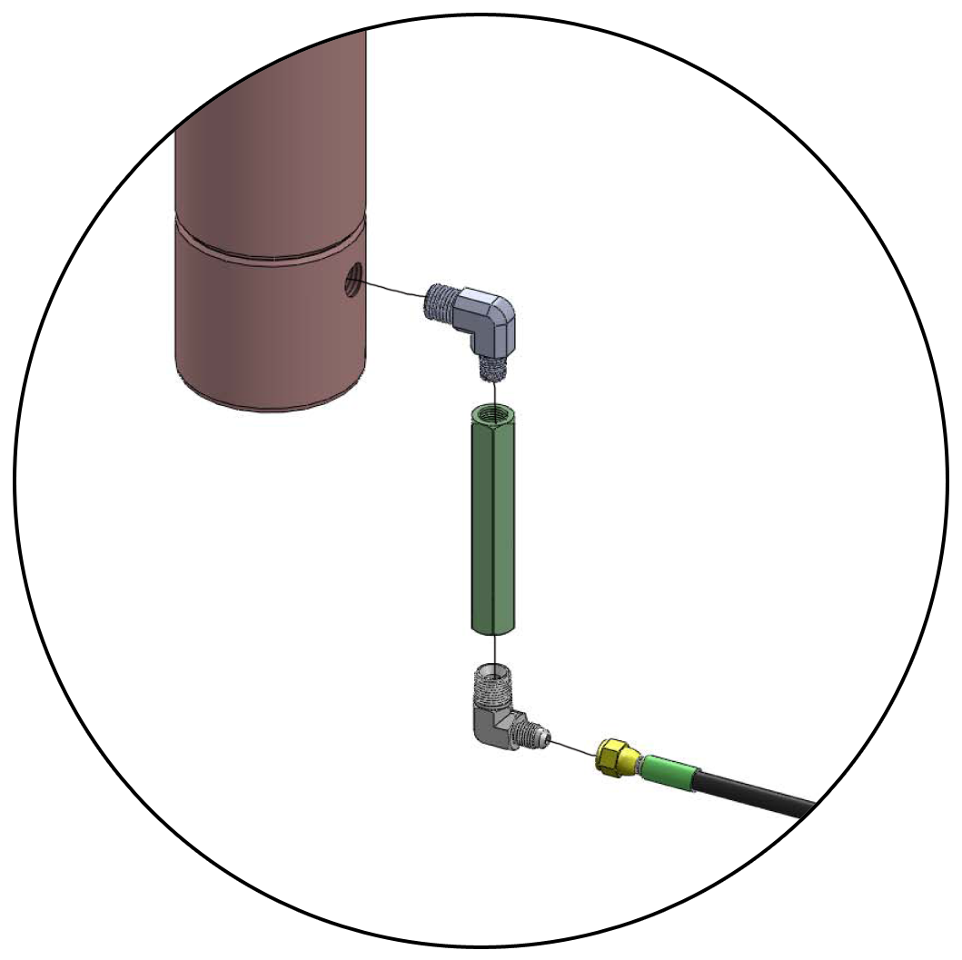
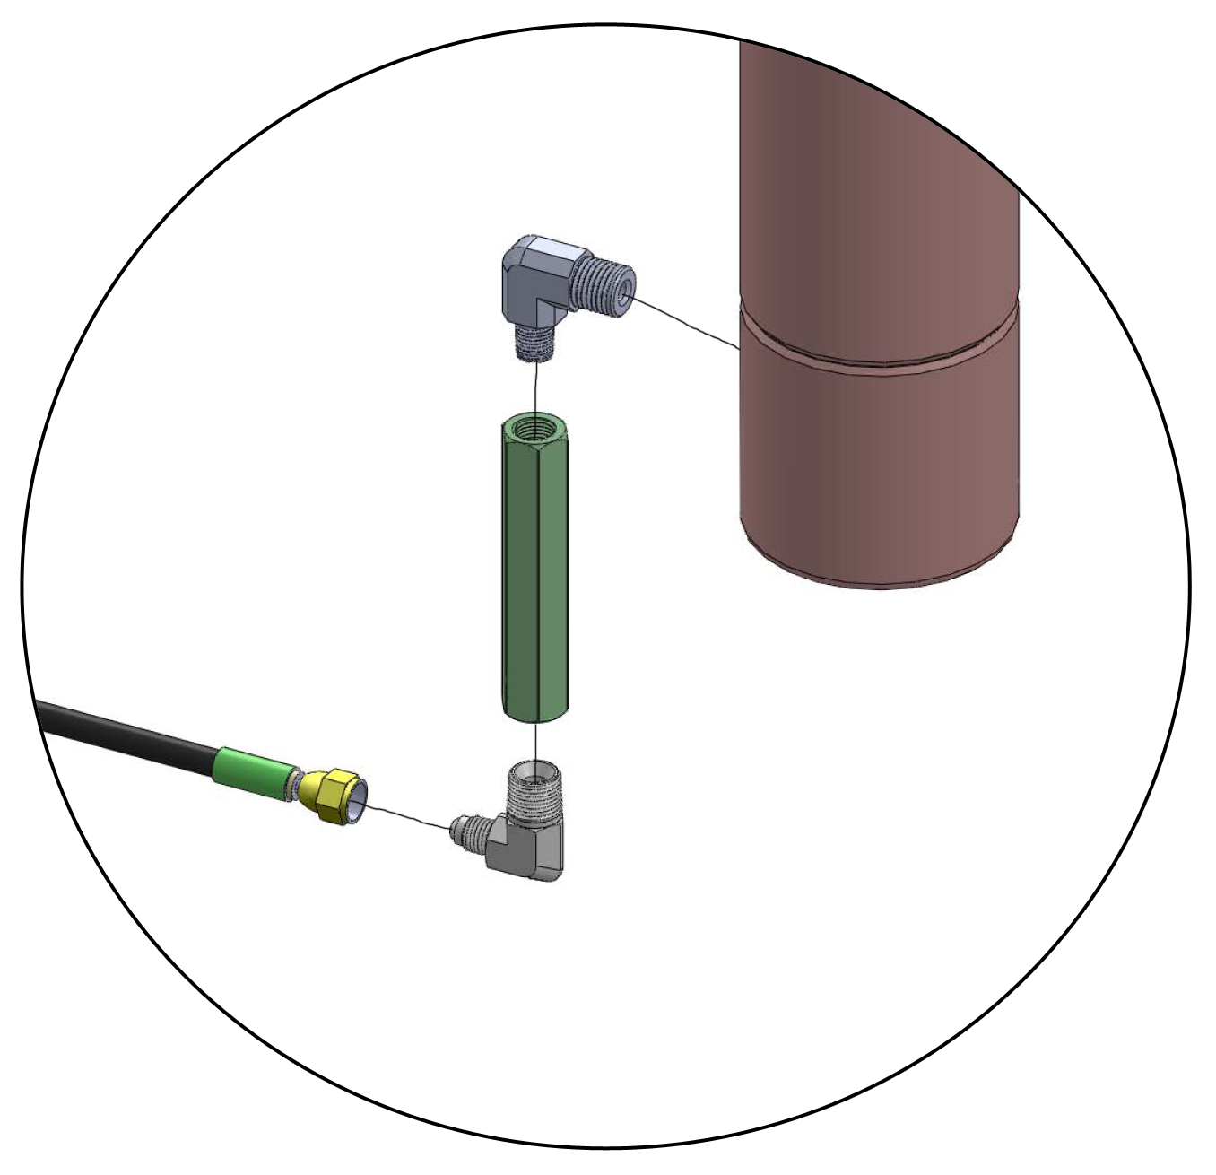
78
82
78A
78
76A
77
78
78
76

Fig. 15

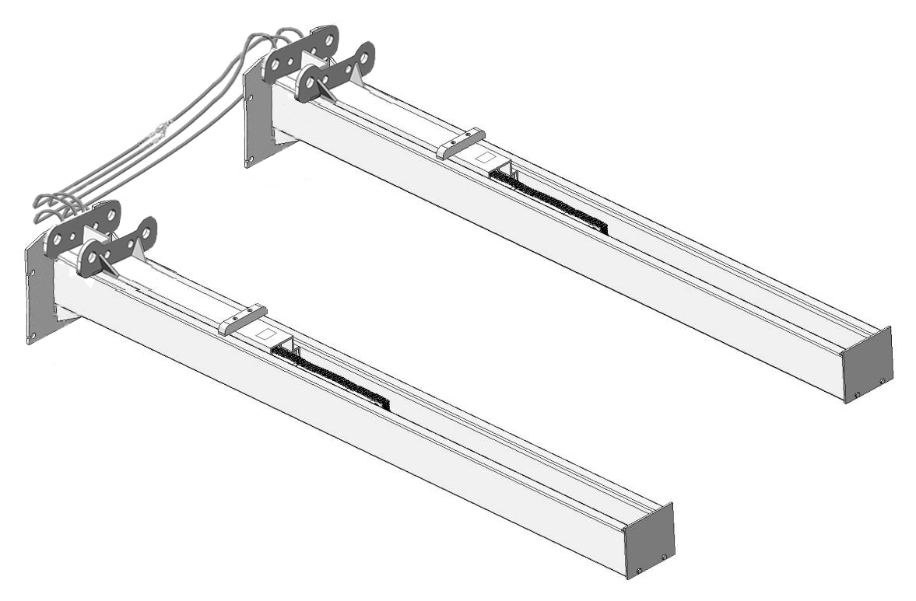
2. Push the carriages to the bottom of columns (See Fig. 16).

Push the carriages to the bottom of columns

Fig. 16

G. Position columns (See Fig. 17)
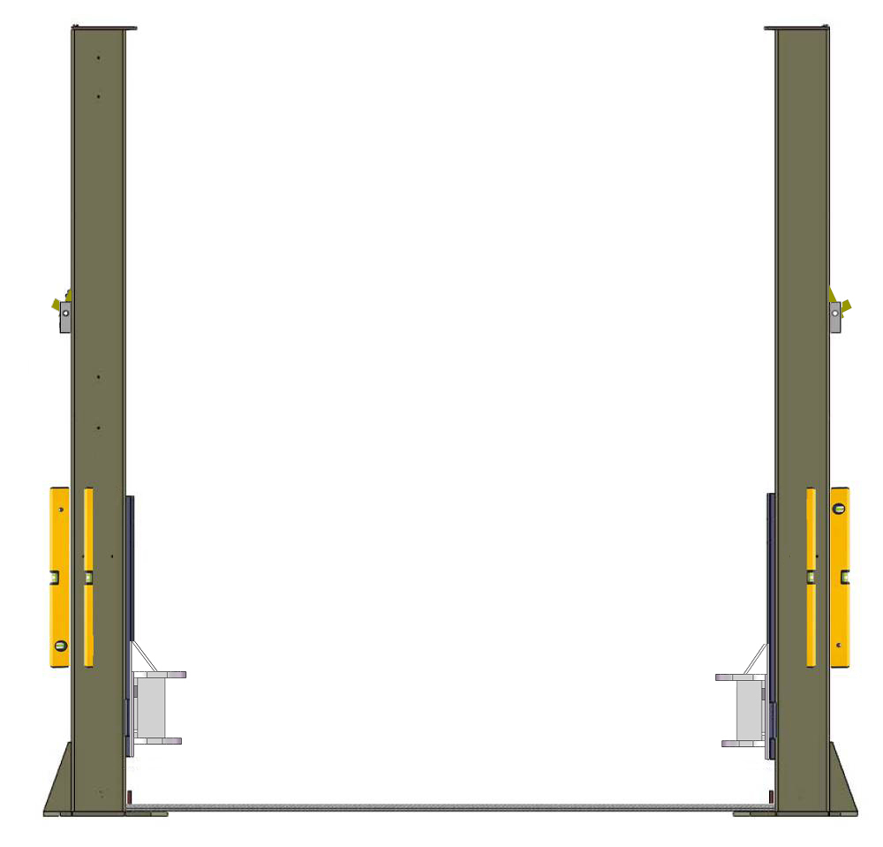
Check the columns plumbness with level bar, and adjusting with the shims if the columns are not vertical.

2850mm

Check the columns plumbness with level bar on front and side column

Cable and oil hose can not cross
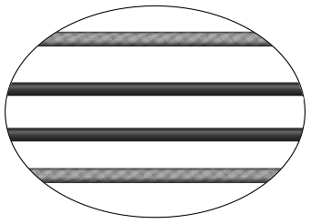
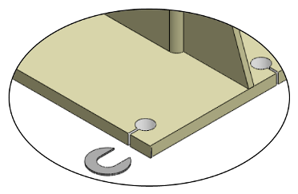

94/94A
3460mm

Fig. 17
H. Fix anchor bolts
1. Prepare anchor bolts (See Fig. 18).
95
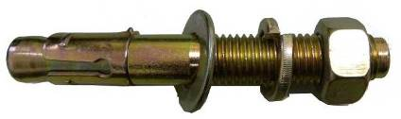

Fig. 18

2. Using the prescribed rotary hammer drill, and drill all the anchor holes and install the anchor bolts. Then tighten the anchor bolts (See Fig. 19).
Note: Torque of Anchors is 150N.m.Minimum embedment of anchors is 90mm.
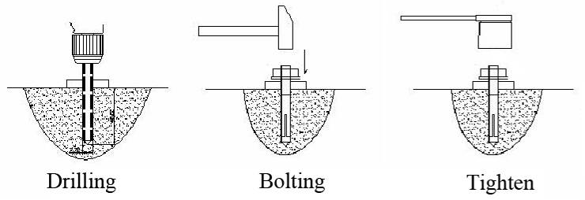

90mm

Fig. 19
I. Lift the carriages up by hand and make them be locked at the same level
(See Fig. 20).

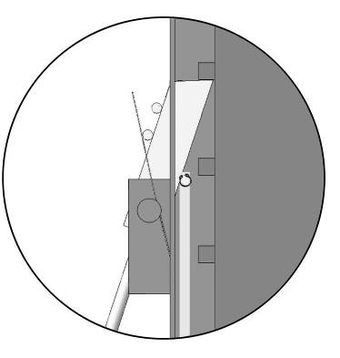
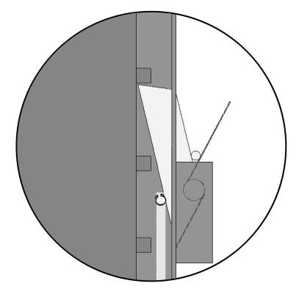

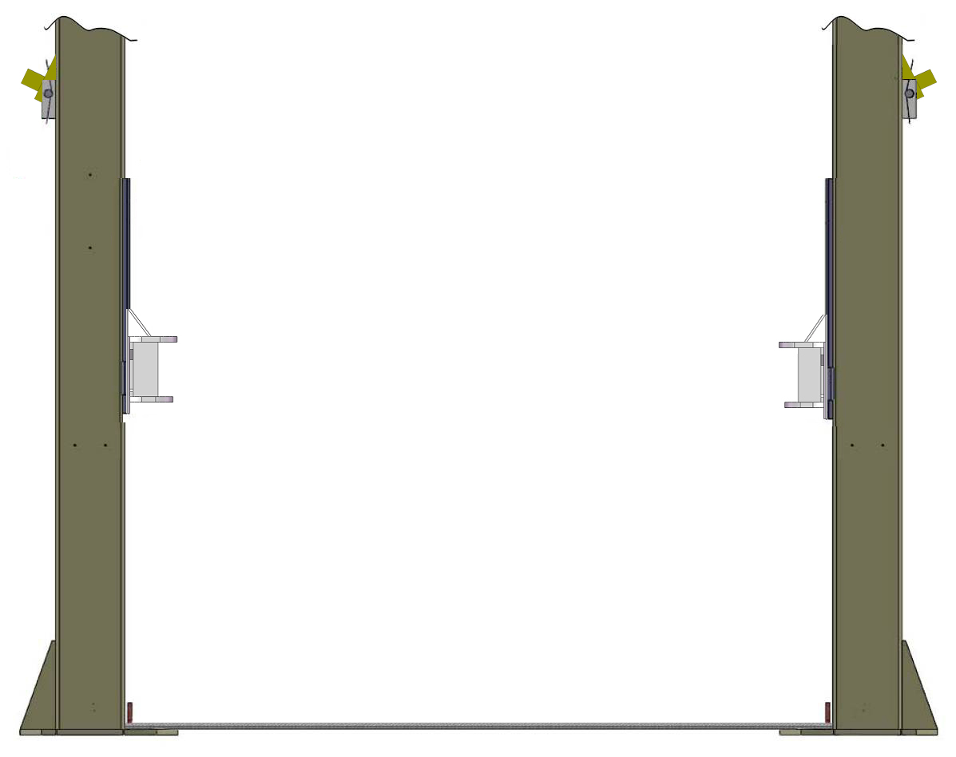

Fig. 20

J. Install safety device and safety cable (See Fig. 21).
NOTE: 1. Assemble safety cable from offside safety assy.
2. Pay attention to the connecting direction of safety cable.
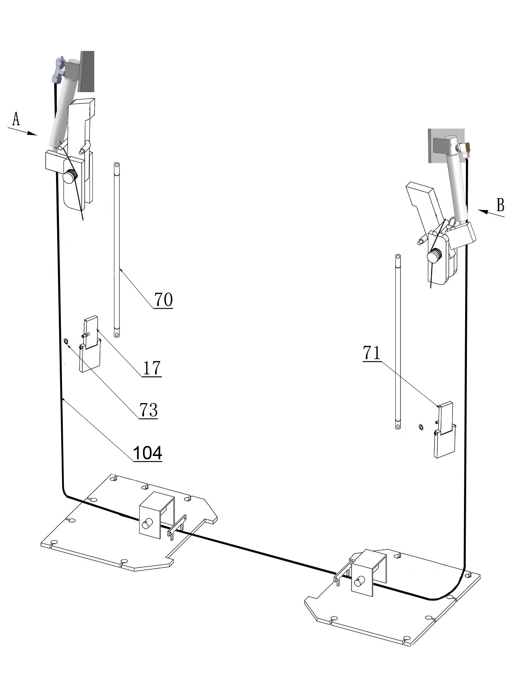
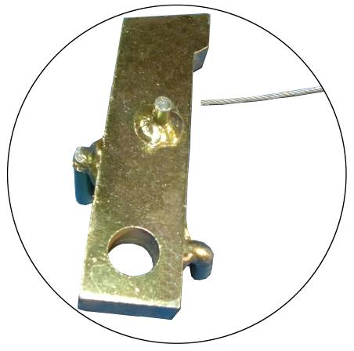

Safety cable
connecting direction
View A

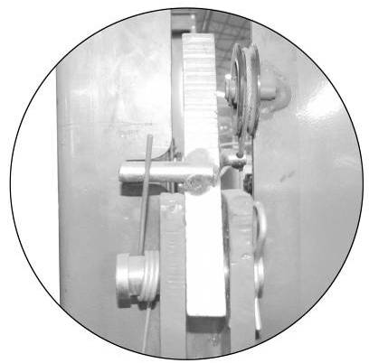
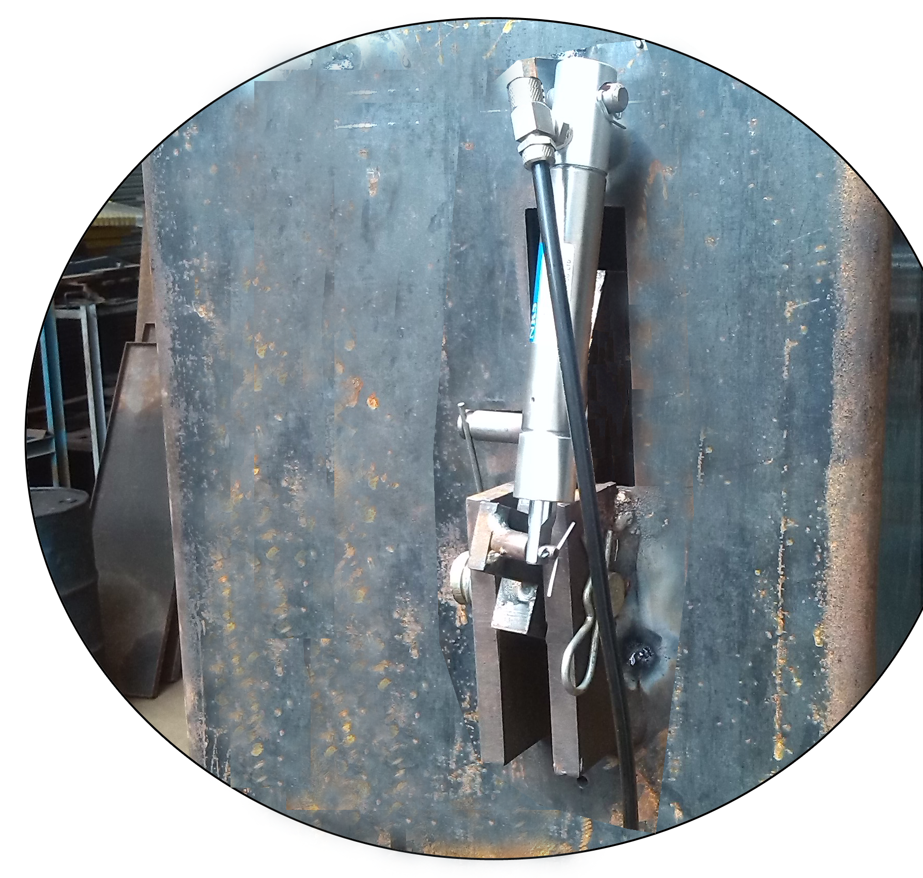
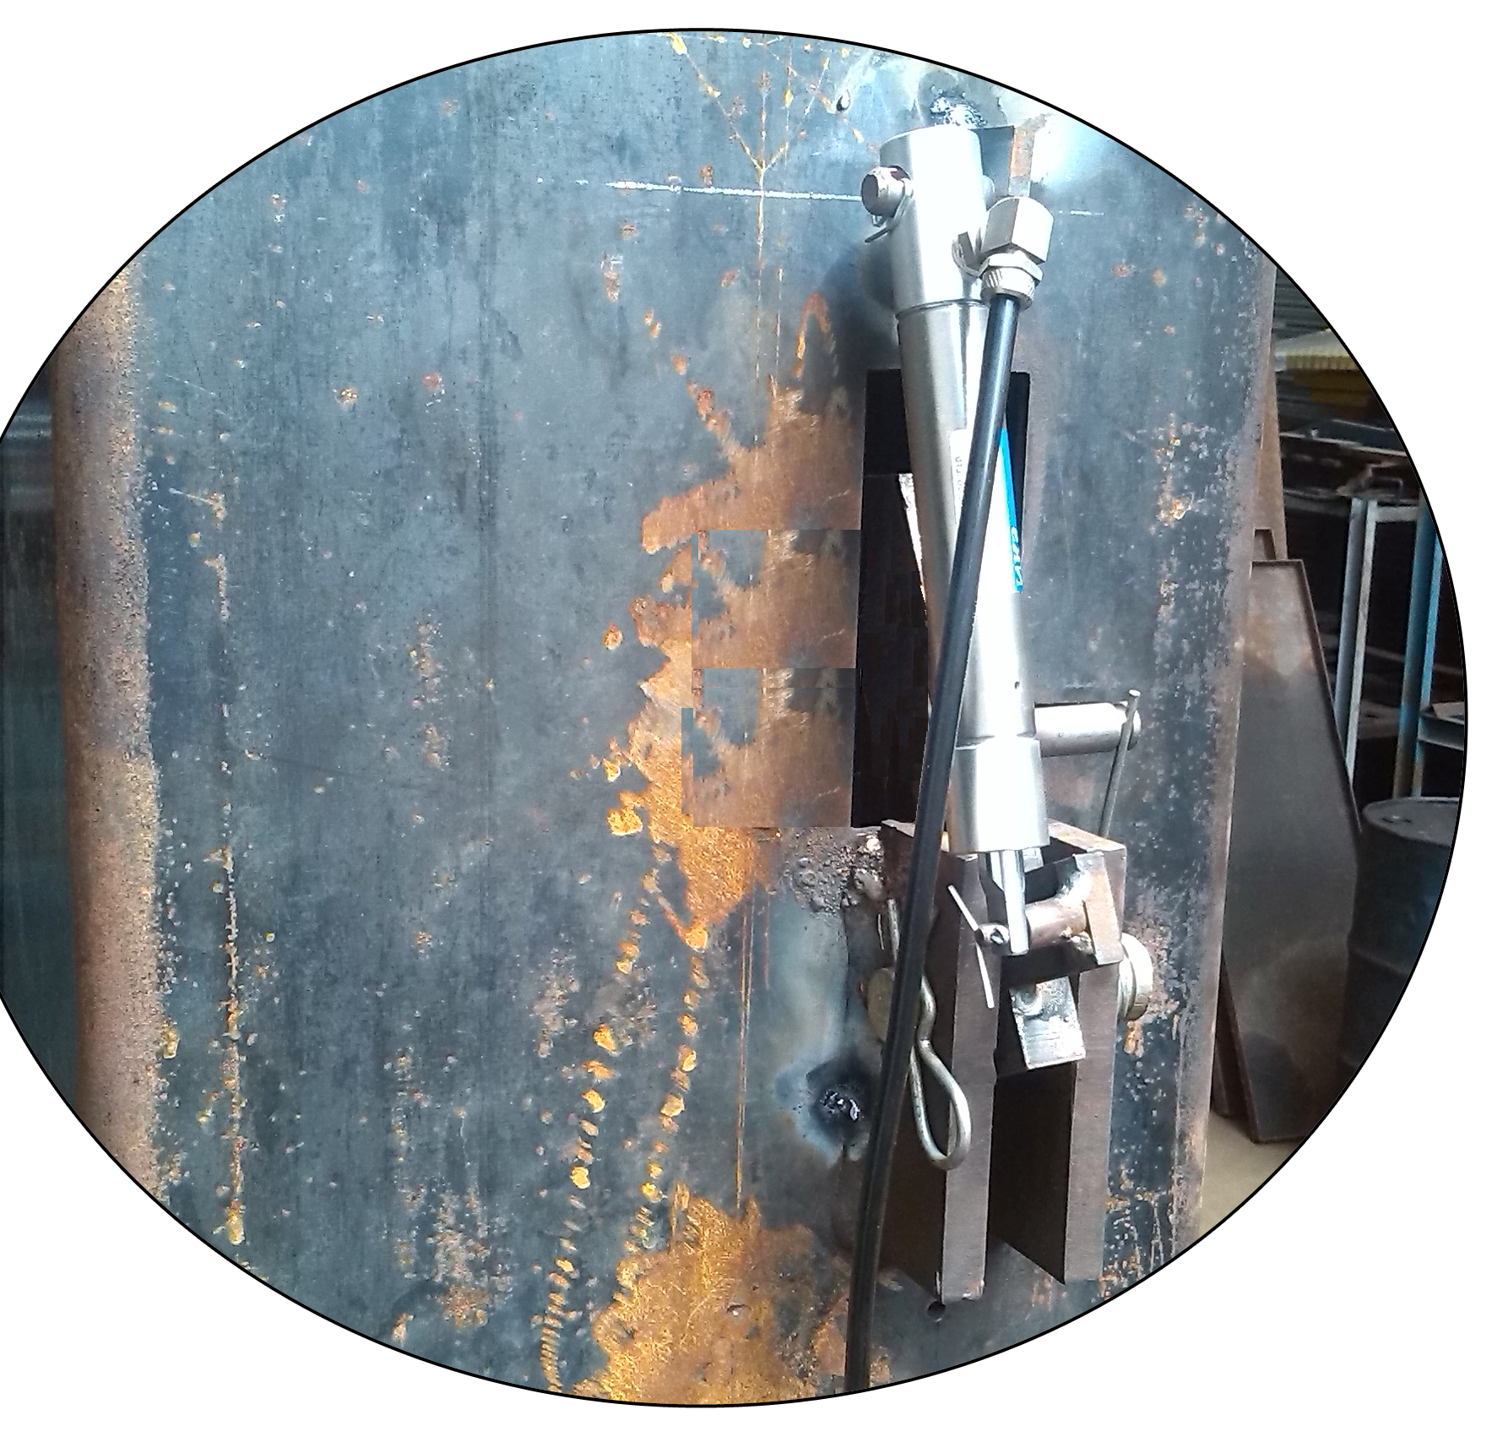

View B

Fig. 21
K. Install hydraulic power unit and oil hose assy. (See Fig. 22).
Tighten all the hydraulic fittings, and fill the reservoir with hydraulic oil.
Note: In consideration of Power Unit’s durability and keep the equipment running in the perfect condition, please use Hydraulic Oil 46#
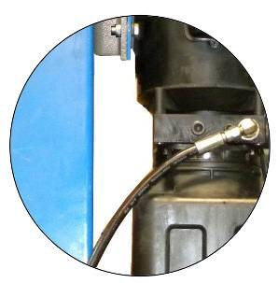

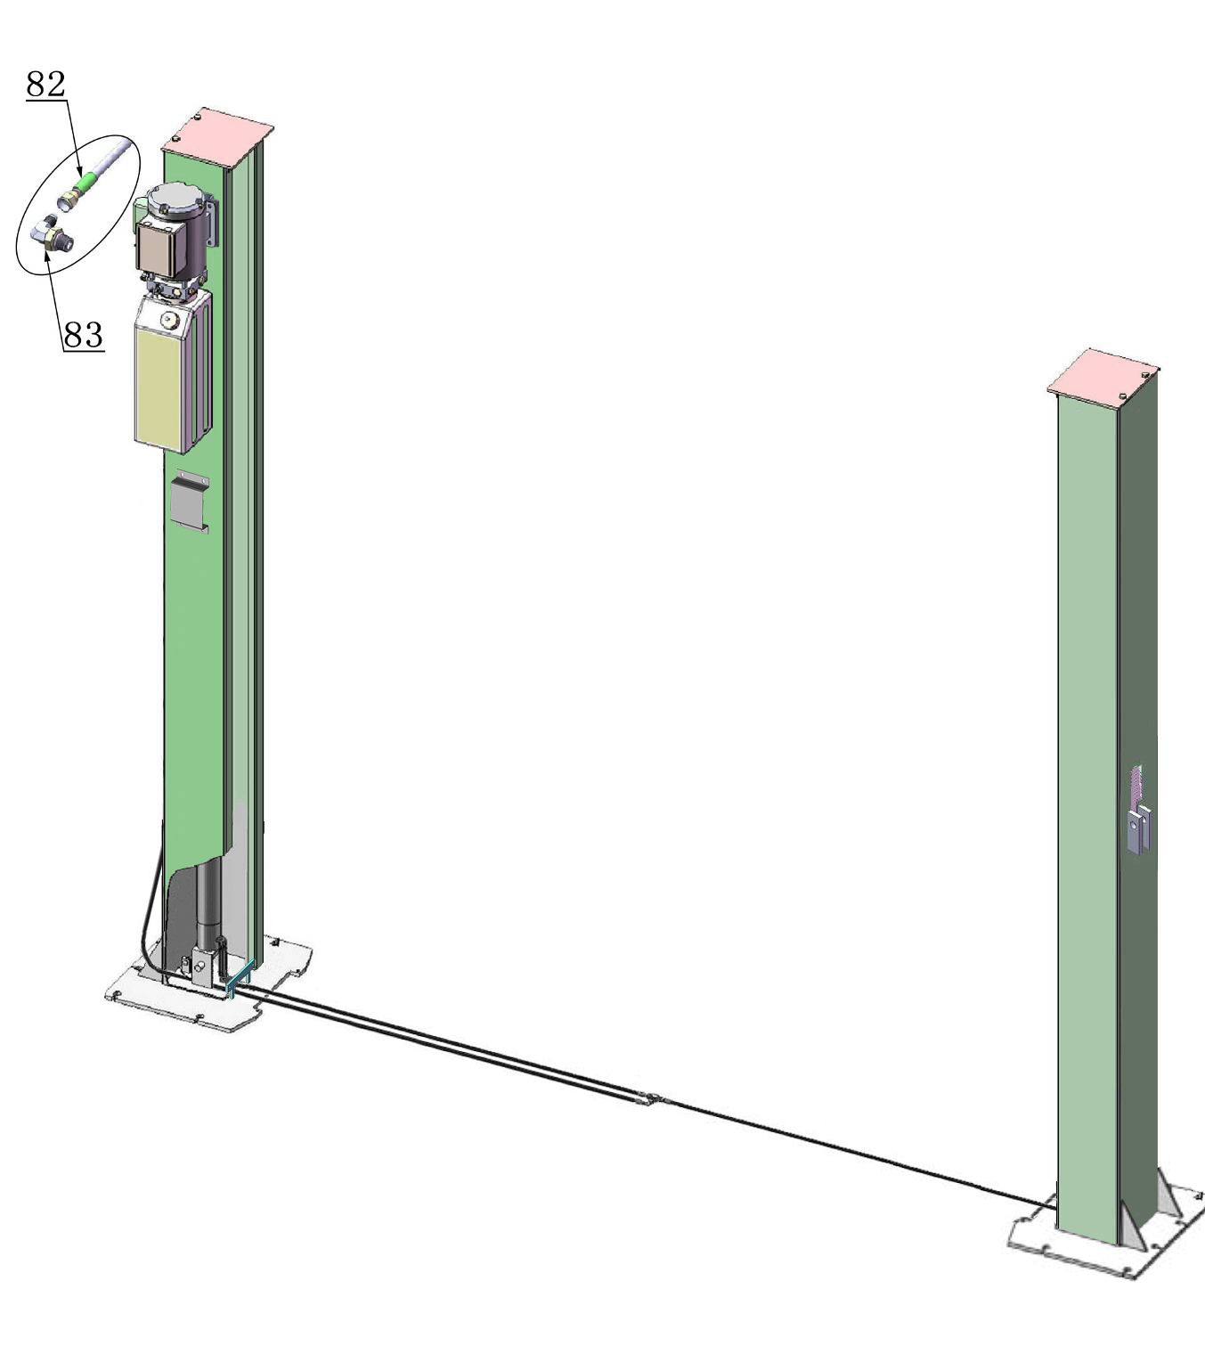

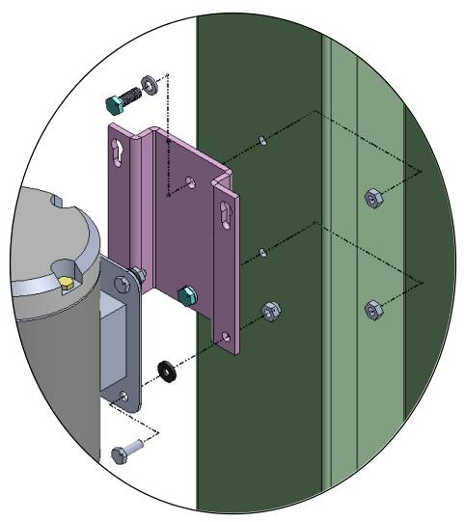
27
80
81
44
3
200

4
2
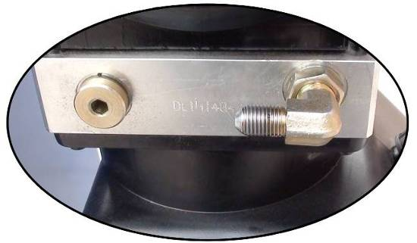

Locking the nut using 19# ratchet spanner

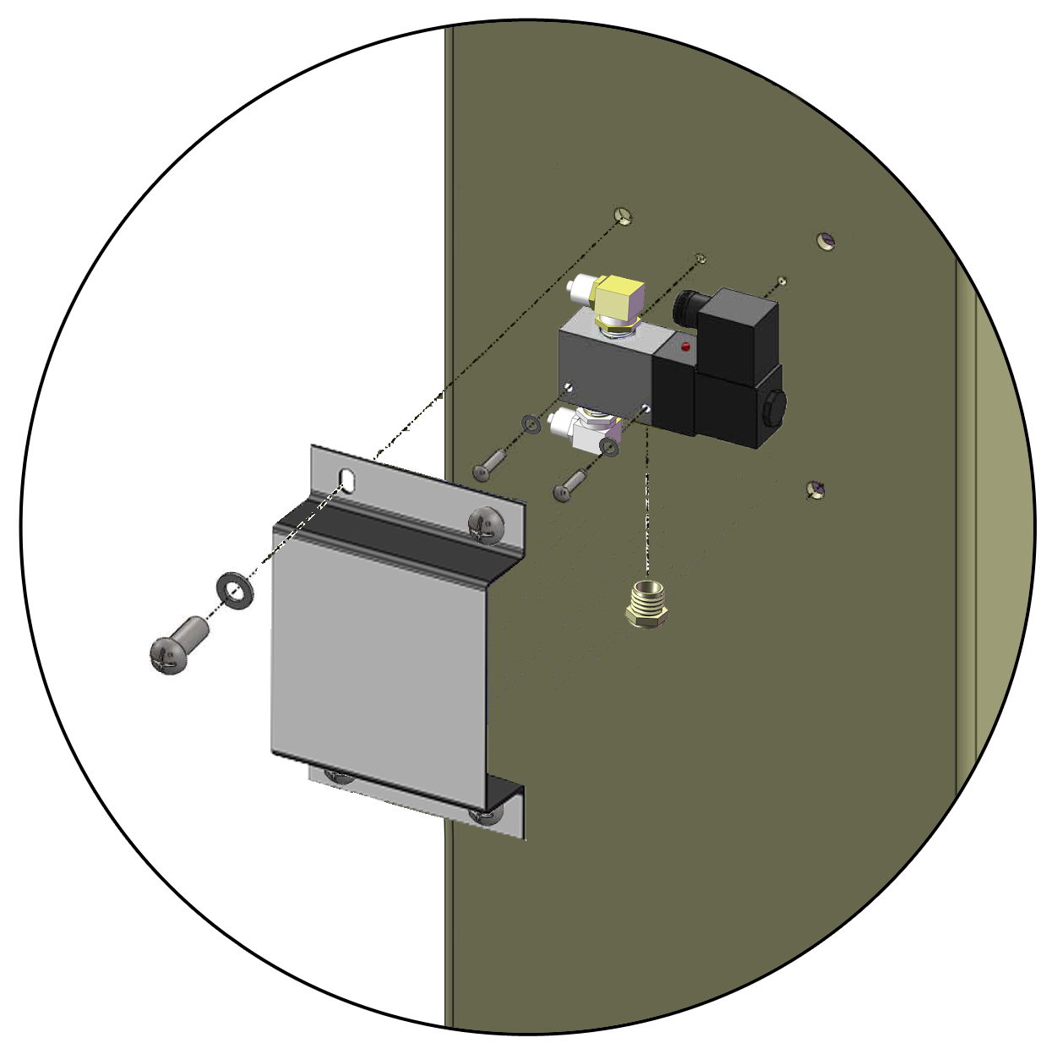
111
105
106
112

107

108
Fig. 22
109

L. Install control box, limit switch and chain cover. (See Fig. 23).
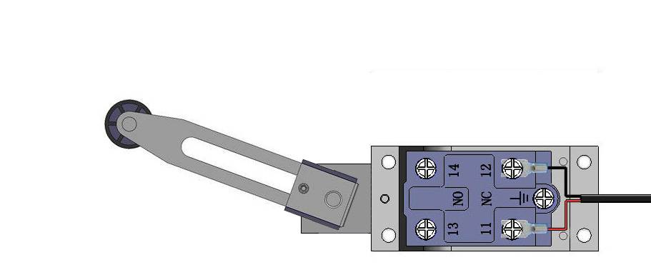
Wire connection of limit switch

Note: when installing the plastic plate, the plastic plate can be adjusted by the adjustable screw rod.
20º

55

3 #
5 #

Connecting 11# & 12# (NC) of limit switch to terminals 3# & 5# of control box

86
87
93

85
6
91

89
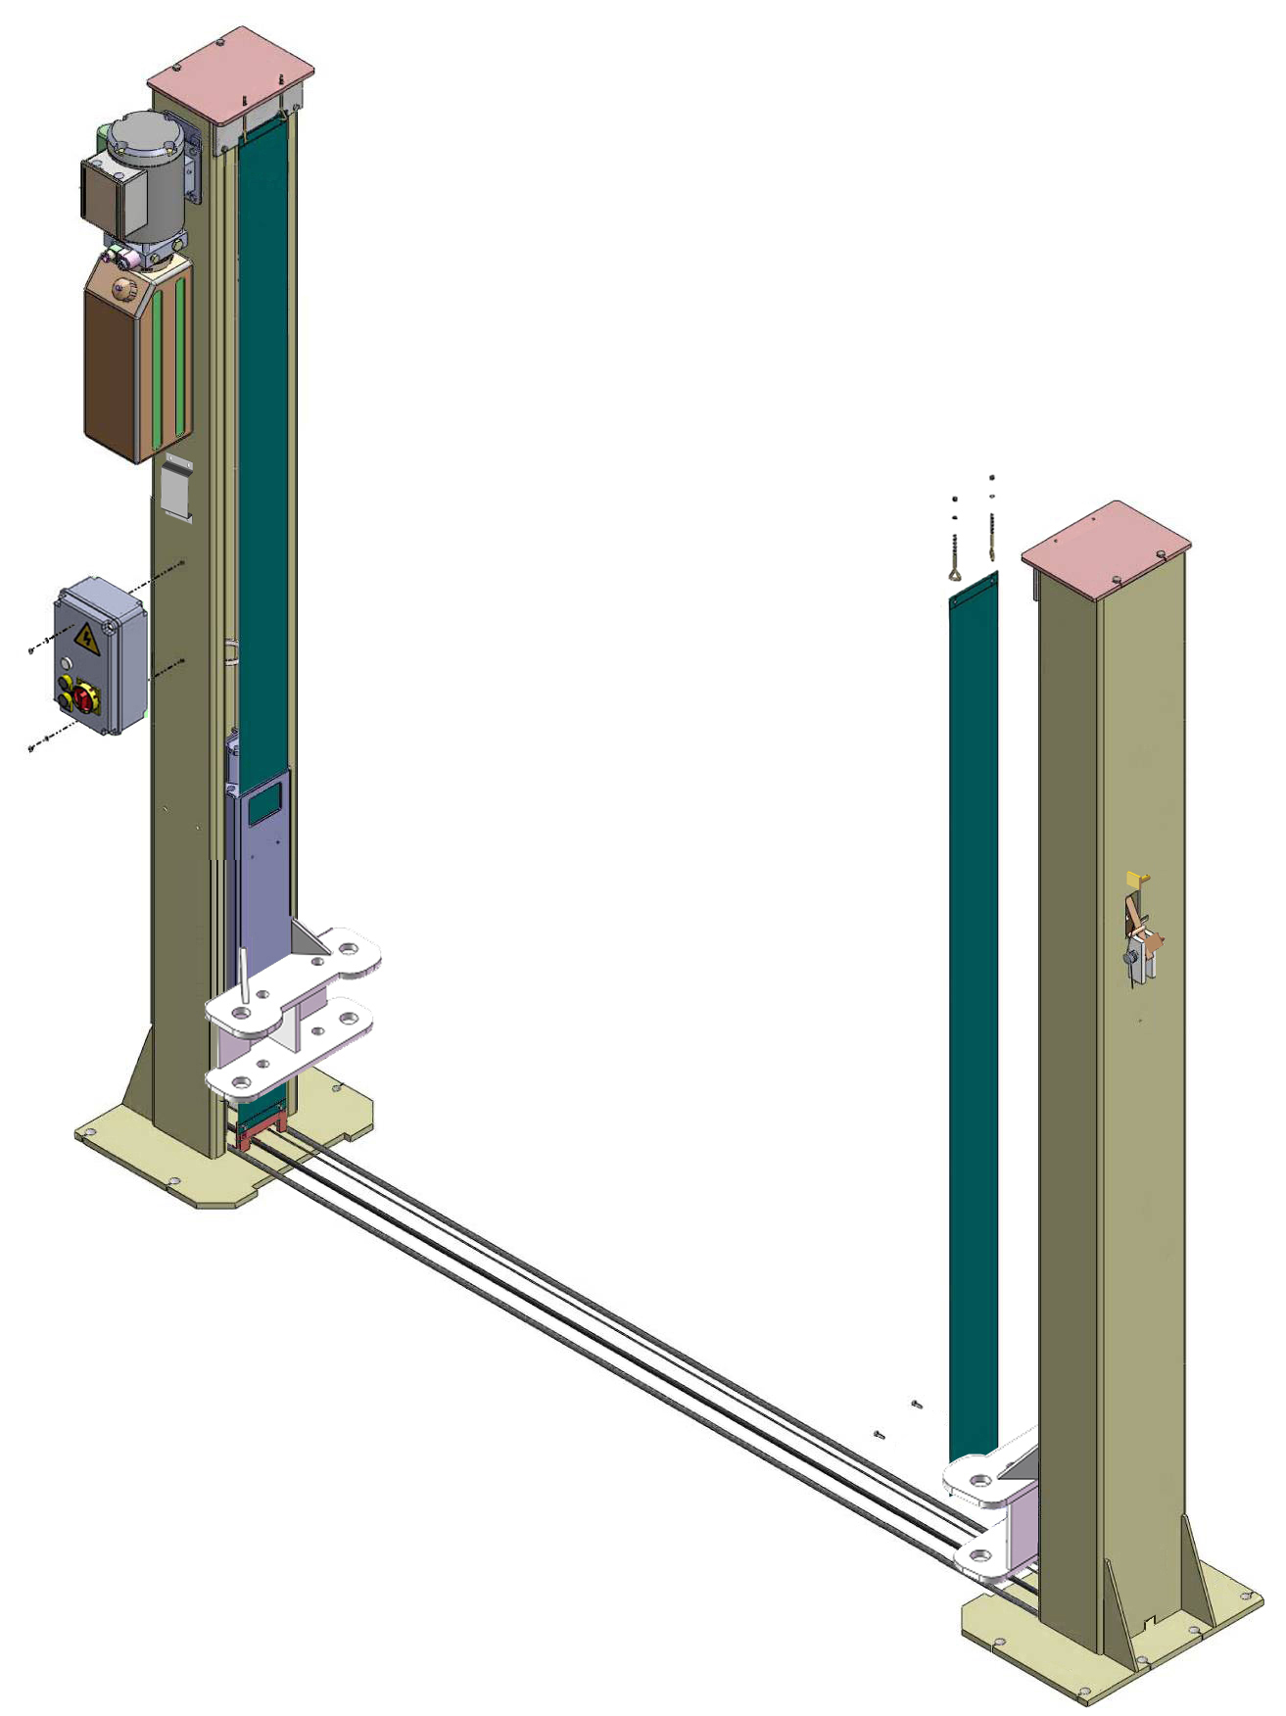
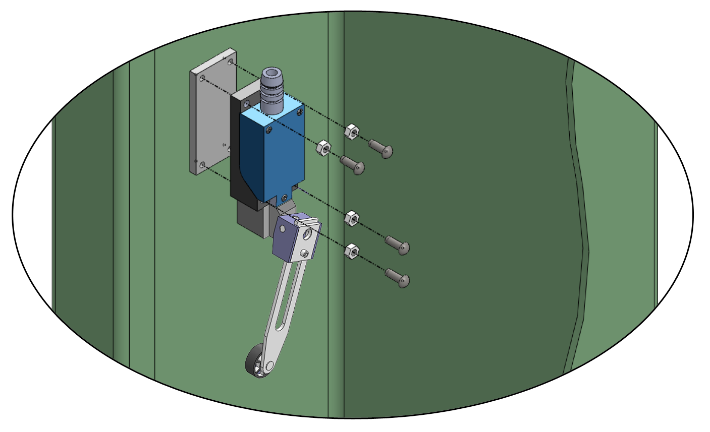
Carriage reinforced plate

88
84
89
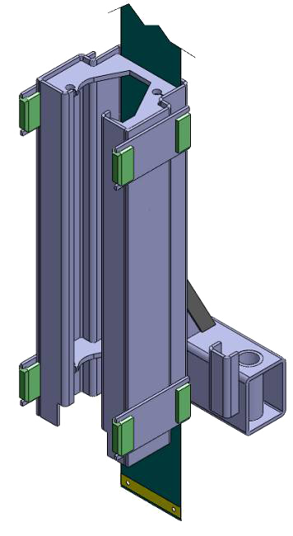
Carriage

90

Chain cover through from the gap between the carriage and Carriage reinforced plate

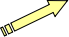

7

Fig. 23
M. Install electrical system
1. Connecting wire with control box (See Fig. 24).
Note: 1) Specification of wire of limit switch and hydraulic solenoid valve is 2×1²
2) Wire cable for power source and motor are 4×2.5²
3) Using white bobbin to wind around wire

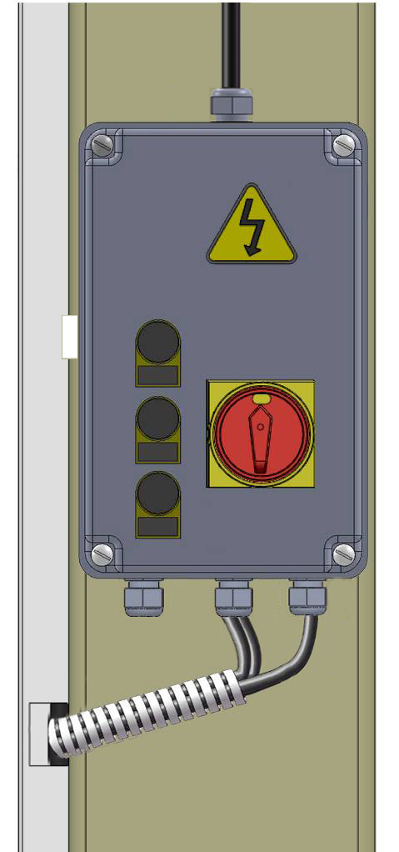
98
97
96
102
Connecting wire of limit switch

Connecting wire of motor

Connecting wire of power

Connecting wire of Air solenoid valve

Connecting wire of hydraulic solenoid valve

99

Fig. 24

2. Adjusting the current rating of thermal relay in control box according to the different configurations of hydraulic power unit. In general, the electric current of thermal relay should equal or larger than that of motor. The following table shows rated current regulation of thermal relay in case of different hydraulic power unit.

Hydraulic power unit | 220V  3HP | 380V  3HP
Rated current of thermal relay | 16A | 12A

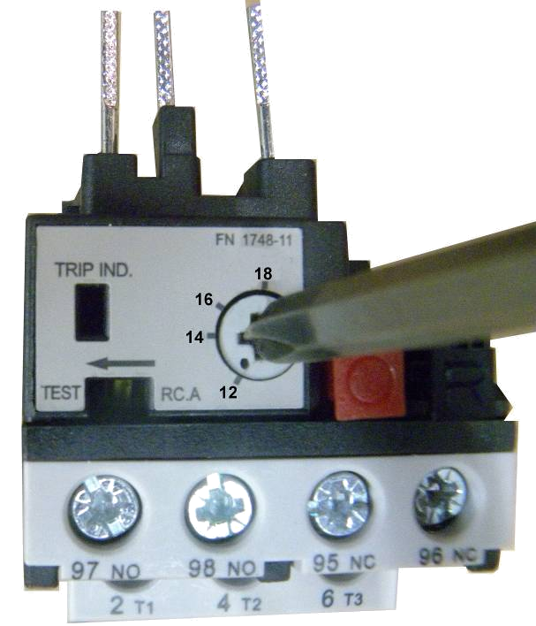

Using cross screwdriver to adjust rated current value of thermal relay
This point shows the present rated current value

Fig. 25

3. 380V Wire connection and circuit diagram
3.1 Wire connection diagram in the control box (See Fig. 26).

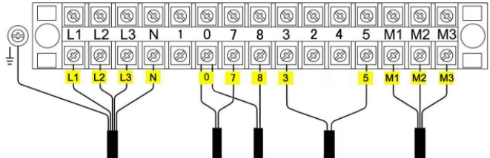
Wire of motor
Wire of hydraulic solenoid valve
Wire of limit switch
Power wire
Earth wire
Wire of Air solenoid valve

Fig. 26

3.2 380V Wire connection diagram of hydraulic motor (See Fig. 27).
Motor wire (M1、M2、M3) are connected to the three wires in the motor.
Turn on the power, push UP button, if motor run but lift is not worked, pls. change the wires connection.

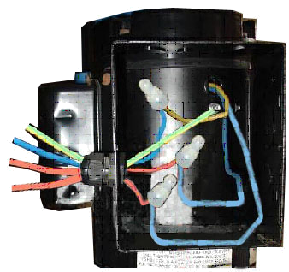
Earth wire

M3
M2
M1

Fig. 27

3.3 380V Circuit diagram (See Fig. 28).
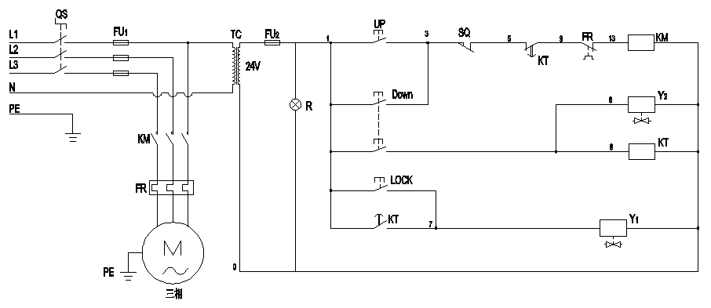

Fig. 28
3 phase

Circuit diagram component list For 380V Power

Item | Name | Code | Specification |  | Item | Name | Code | Specification
1 | Power Switch | QS | 25A |  | 9 | Air Solenoid Valve | Y₂ | 24V AC
2 | Fuse | FU₁ | 25A |  | 10 | Push Button | UP | Single
3 | Fuse | FU₂ | 3A |  | 11 | Push Button | Down | Duplex
4 | AC Contactor | KM | 16A 24V AC |  | 12 | Push Button | LOCK | Single
5 | Thermal relay | FR | 12A~18A |  | 13 | Transformer | TC | 24V AC
6 | Time relay | KT | 24V AC |  | 14 | Motor | M | 3 phase
7 | Limit Switch | SQ | 10A |  | 15 | Indicating lamp | R | 24V
8 | Hydraulic Solenoid Valve | Y₁ | 24V AC
4. 220V Wire connection and circuit diagram
4.1 Wire Connection diagram in the control box (See Fig. 29).
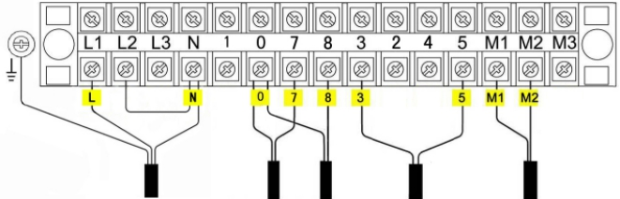
Power wire

Wire of hydraulic solenoid valve

Wire of limit switch
Wire of motor
Earth wire
Wire of Air solenoid valve

Fig. 29
4.2 220V Wire connection of hydraulic power unit (See Fig. 30).
Motor wire (M1、M2) separately connected to two wires in the motor
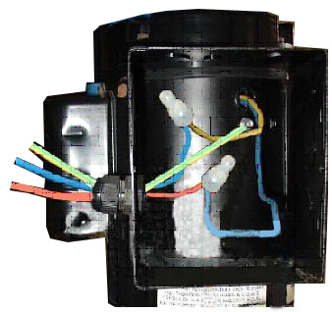

Earth wire

M2
M1

Fig. 30

4.3 220V Circuit diagram (See Fig. 31).
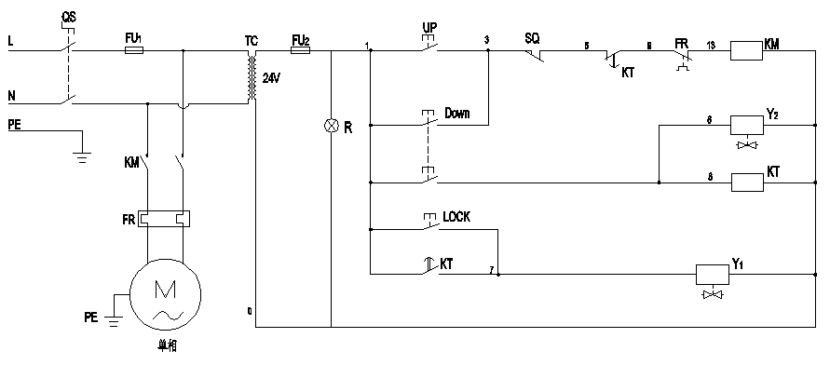

Single phase
Fig. 31
Circuit diagram component list For 220V Power
Item | Name | Code | Specification |  | Item | Name | Code | Specification
1 | Power Switch | QS | 25A |  | 9 | Air Solenoid Valve | Y₂ | 24V AC
2 | Fuse | FU₁ | 25A |  | 10 | Push Button | UP | Single
3 | Fuse | FU₂ | 3A |  | 11 | Push Button | Down | Duplex
4 | AC Contactor | KM | 16A 24V AC |  | 12 | Push Button | LOCK | Single
5 | Thermal relay | FR | 12A~18A |  | 13 | Transformer | TC | 24V AC
6 | Time relay | KT | 24V AC |  | 14 | Motor | M | Single phase
7 | Limit Switch | SQ | 10A |  | 15 | Indicating lamp | R | 24V
8 | Hydraulic Solenoid Valve | Y₁ | 24V AC

N. Install protective cover and safety cover (See Fig 32).

Step of installing protective cover:
1.Screw the head cup bolt M6*40
100
2.Install the protective cover and tight up the head cup bolt

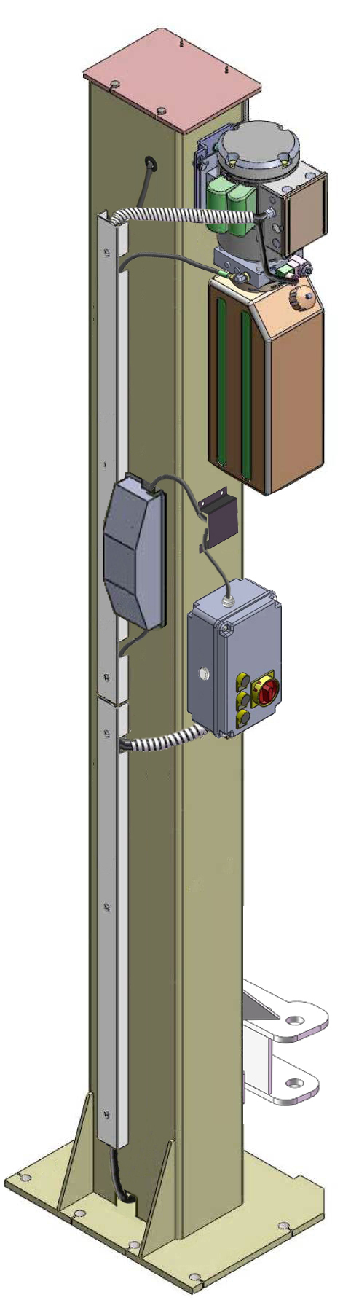
Wire of hydraulic solenoid valve
Wrap around wire
104
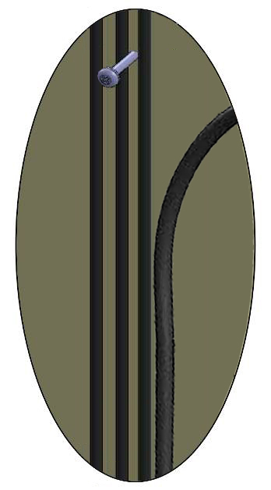

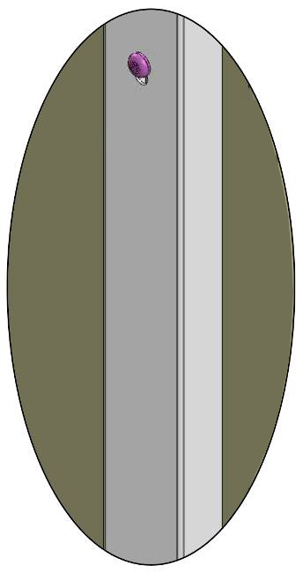
Wire of motor

Wire of limit switch
103
Oil hose for power unit

102

Wrap around wire
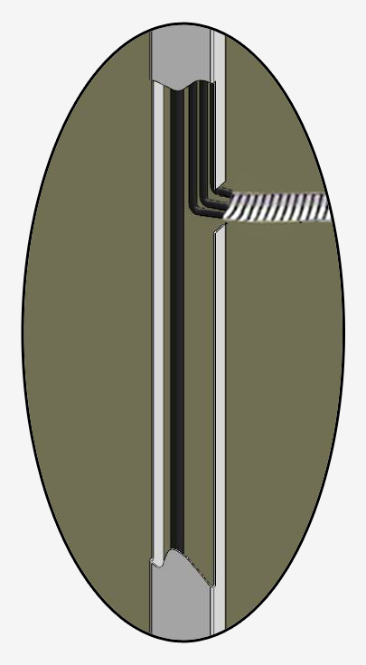

Fig. 32

O. Install floor cover, protective rubber and lifting arms (See Fig 33).

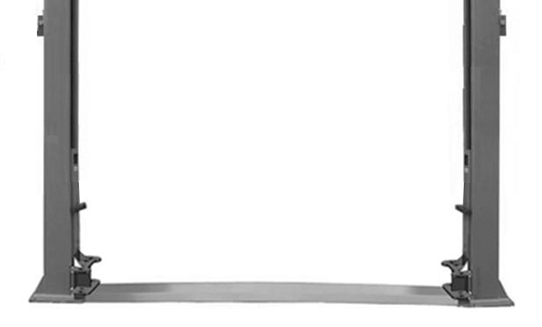
Floor cover

Fig.33

P. Adjust the arm locks
1. After installing the arms (See Fig.34).
2. lowering the carriages down to the lowest position, then use the 8# socket wrench to loosen the nut of Moon gear (See Fig. 35).
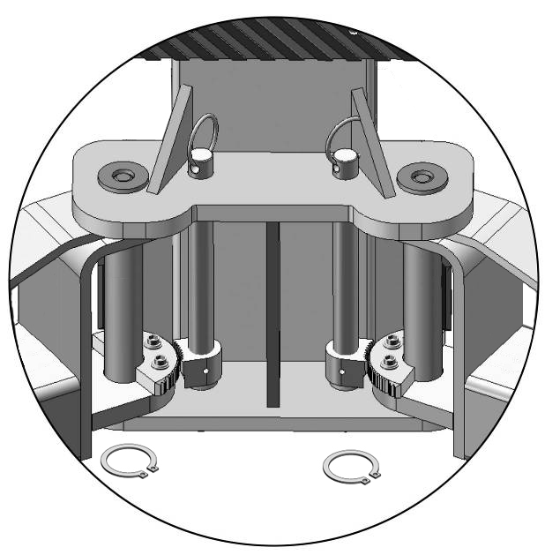
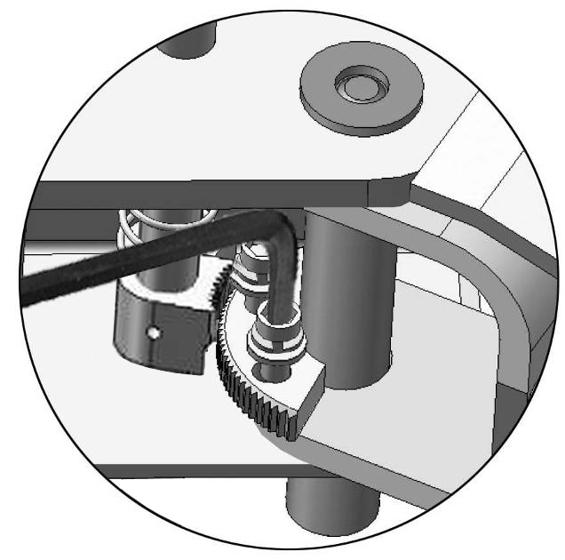

Use the 8# socket wrench to loosen the nut of Moon gear
Snap Ring
Fig. 34
Fig. 35

3. Adjust the arm lock as arrow direction (See Fig. 36).
4. Adjust the moon gear and arm lock to make it to be meshed, then tighten bolts of arm lock (See Fig. 37).

Adjust the arm lock

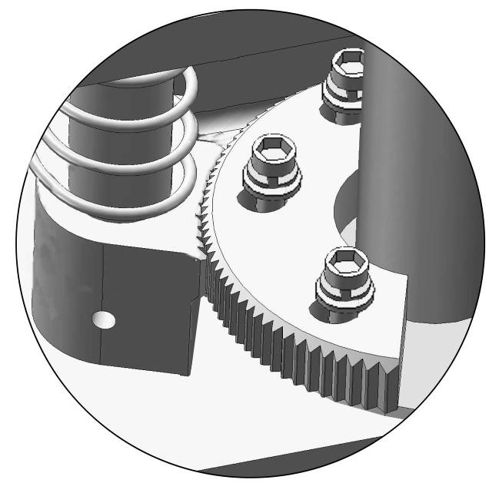
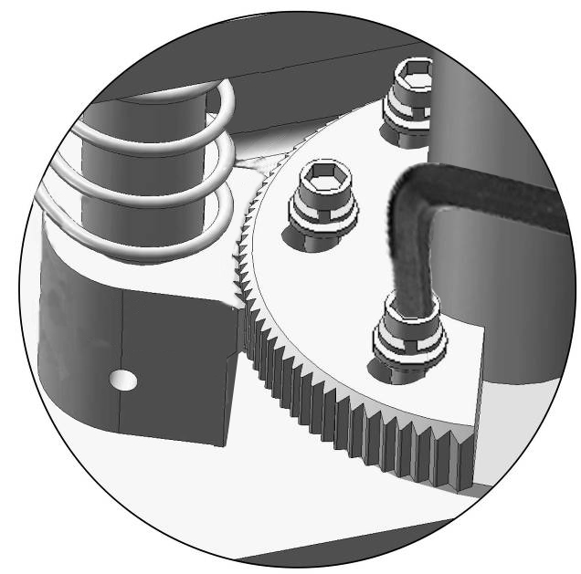
Tighten the bolts

Fig. 36
Fig. 37

IV. EXPLODED VIEW

Model :A240X

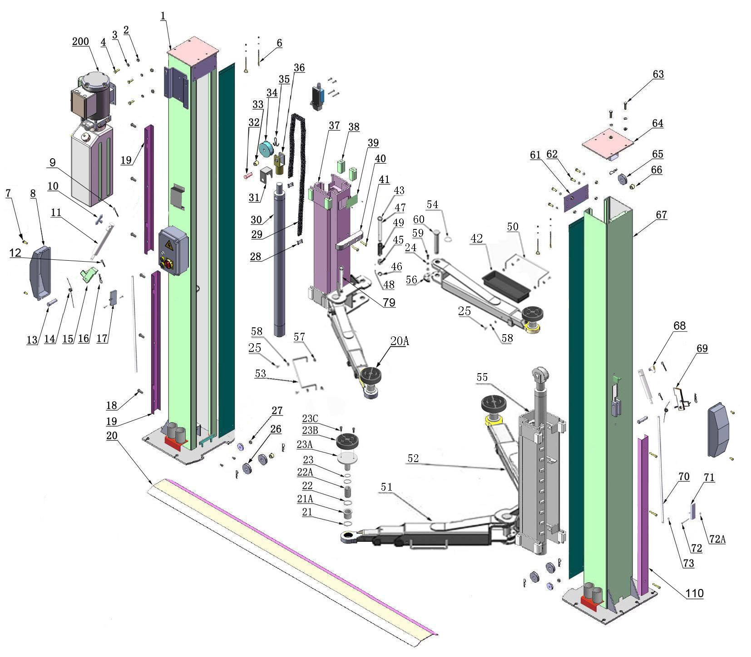

Car in

Fig. 38

Cylinders
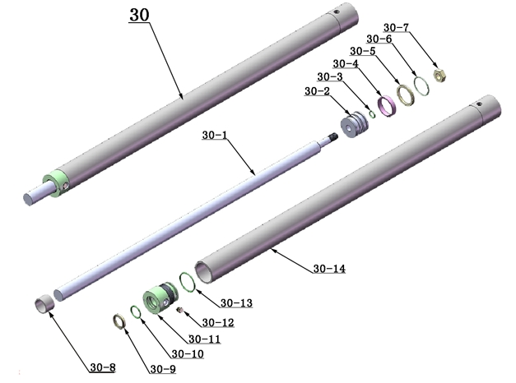

Fig. 39

Control Box
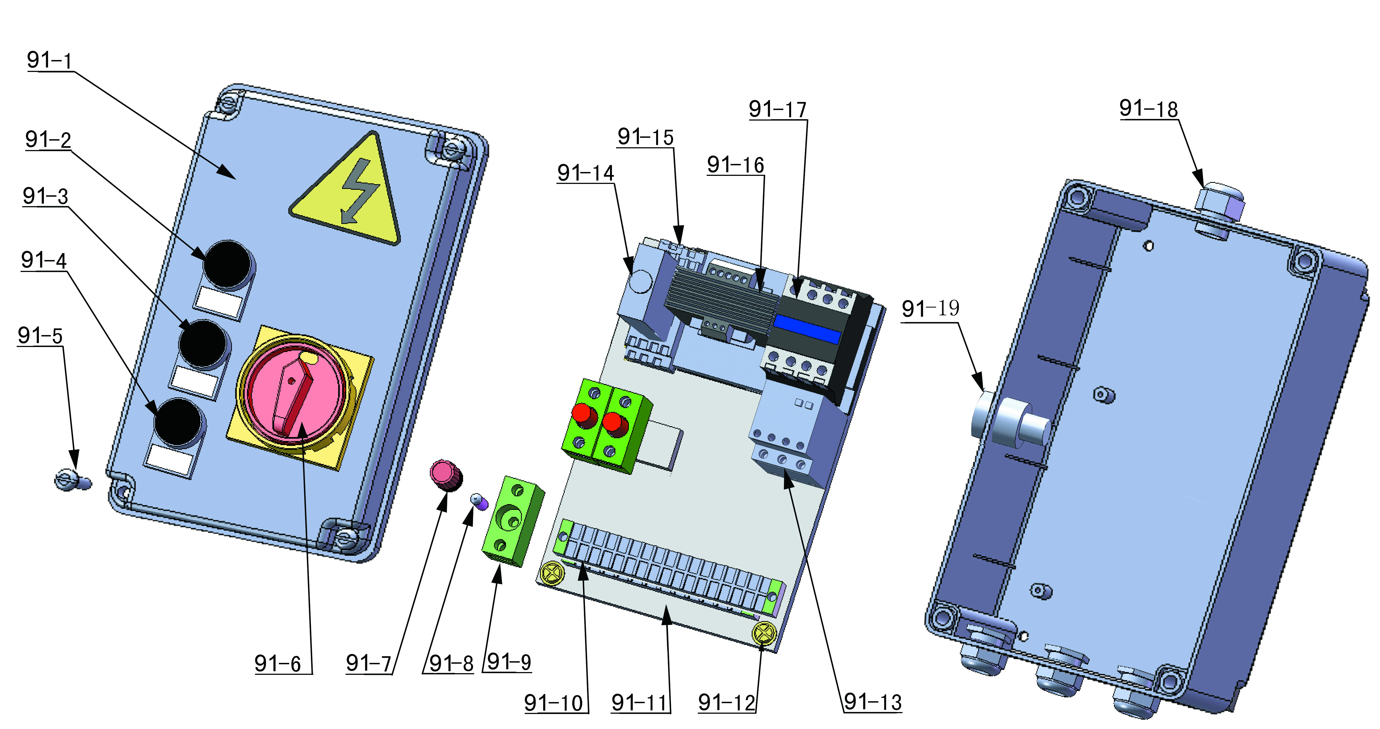

Fig. 40
ELECTRIC POWER UNIT

220V/50HZ/1Phase
380V/50HZ/3Phase

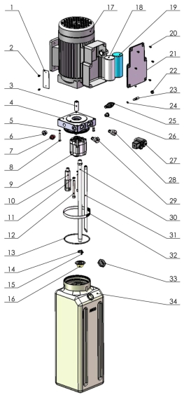
Fig. 41

Illustration of hydraulic valve for power unit
AMGO electric power unit, 220V/50Hz, single phase (See Fig. 42)

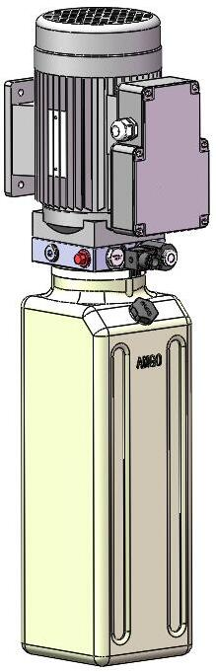
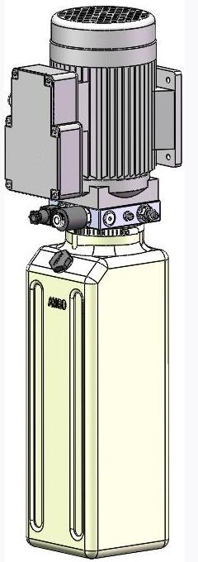

Oil return port
Relief valve

Solenoid valve
Throttle valve

Oil outlet
Check valve

Fig. 42

C. PEAK electric power unit, 380V/50Hz, 3 phase (See Fig. 43)
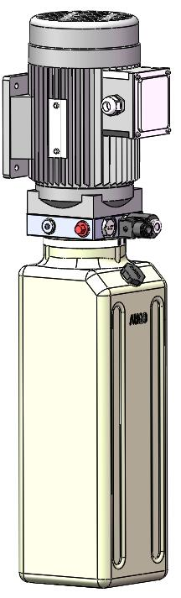
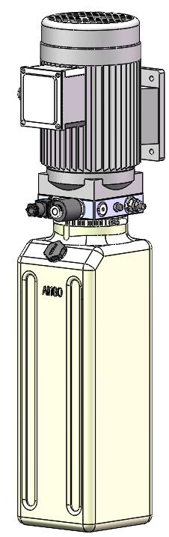

Relief valve
Oil return port

Solenoid valve

Throttle valve

Oil outlet

Check valve

Fig. 43

V. TEST RUN
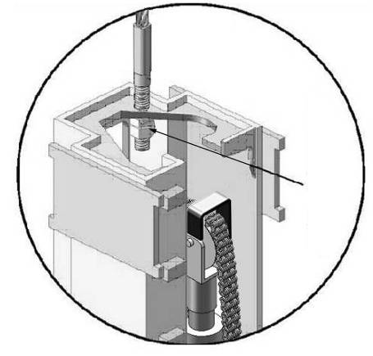
1. Adjust synchronous cable (See Fig. 44)
Press UP button to lift the carriage until the
cable nut higher than chain pulley. Use wrench
to hold the cable fitting, meanwhile use ratchet
spanner to tighten the cable nut. Make sure two
Cable Nut
cables are in the same tension so that two lifting
carriages can work synchronously.
The first safety lock
Fit the plastic hole cover on the lifting head.
Fig. 44
If the carriage does not Synchronize when lifting,
please tighten the cable nut of lower side carriage.

2. Adjust the lower speed
You can adjust the lower speed of the lift if needing: Loosen the fixing nut of the throttle valve, and then turn the throttle valve clockwise to decrease the lower speed, or counterclockwise to increase the lower speed. Do not forget to tighten the fixing nut after the lower speed adjustment has been done. (See Fig. 45)

Throttle valve
Throttle valve
Fixing nut

Fixing nut
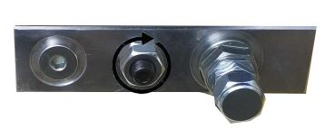

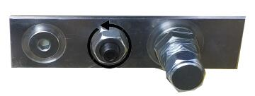

Counterclockwise to increase the lower speed.
Clockwise to decrease the lower speed.

Fig. 45

3. Test with load
After finishing the above adjustment, test running the lift with load. Run the lift in low position for several times first, make sure the lift can rise and lower synchronously, the safety device can lock and release synchronously. And then test run the lift to the top completely. If there are anything improper, repeat the above adjustment.
NOTE: It may be vibrated when lifting at start, please lifting it with load for several times, the air would be bled and the vibration would be disappeared automatically.

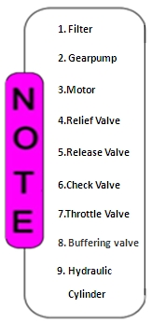
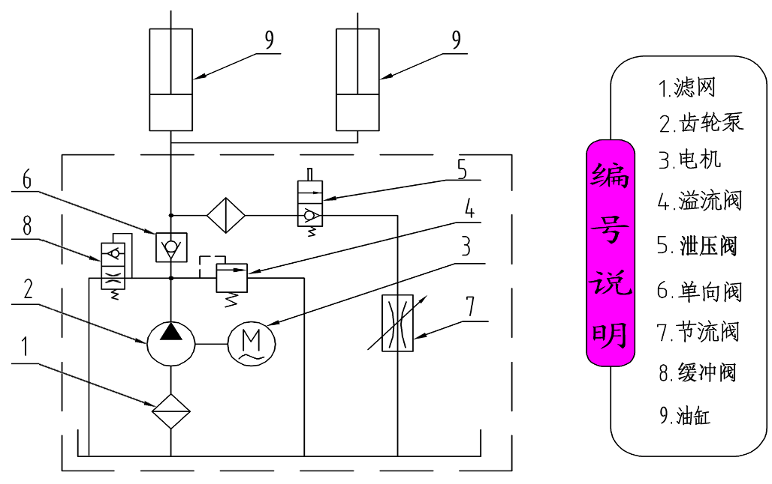

Fig. 46

VI. OPERATION INSTRUCTIONS
Please read the safety tips carefully before operating the lift
To lift vehicle
- Keep clean of site near the lift;
- Position lift arms to the lowest position;
- To shortest lift arms;
- Open lift arms to two sides;
- Position vehicle between columns;
- Move arms to the vehicle’s lifting point;
Note: The four lift arms must at the same time contact the vehicle’s lifting point where manufacturers recommended
- Turn on the power switch (QS1), push button “UP” until the lift pads contact underside of vehicle totally. Recheck to make sure vehicle is secure;
- Continue to raise the lift slowly to the desired working height, ensuring the balance of vehicle;
- push button “DOWN”, lower lift onto the safety position. The vehicle is ready to repair.

To lower vehicle
- Be sure clear of around and under the lift, only leaving operator in lift area;
- push button “UP” to raise the vehicle slightly, and then release the safety device, push button “DOWN” to lower lift.
- Open the arms and position them to the shortest length;
- Drive away the vehicle.
- Turn off the power.

VII.MAINTENANCE SCHEDULE
Monthly:
- Re-torque the anchor bolts to 150 Nm;
- Check all connectors, bolts and pins to insure proper mounting;
- Lubricate cable with lubricant;
- Make a visual inspection of all hydraulic hoses/lines for possible wear or leakage;
- Check Safety device and make sure proper condition;
- Lubricate all rollers and pins with 90wt. Gear oil or equivalent;
Note: All anchor bolts should take full torque. If any of the bolts does not function for any reason, DO NOT use the lift until the bolt has been replaced.
Every six months:
- Make a visual inspection of all moving parts for possible wear, interference or damage.
- Check and adjust as necessary, equalizer tension of the cables to insure level lifting.
- Check columns for plumbness.
- Check rubber pads and replace as necessary.
- Check safety device and make sure proper condition.

VIII.TROUBLE SHOOTING
TROUBLE | CAUSE | REMEDY
Motor does not run | 1. Button does not work  2. Wiring connections are not in good condition  3. Motor burned out  4. AC contactor burned out | 1. Replace button  2. Repair all wiring connections  3. Repair or replace motor  4. Replace AC contactor
Motor runs but the lift is not raised | 1. Motor runs in reverse rotation  2. Gear Pump out of operation  3. Release Valve in damage  4. Relief valve or check valve in damage  5. Low oil level | 1.Reverse two power wire  2.Repair or replace  3.Repair or Replace  4.Repair or replace  5.Fill tank
Lift does not stay up | 1. Release valve out of work  2. Relief valve or check valve leakage  3. Cylinder or fittings leaks | Repair or replace
Lift raises slowly | 1. Oil line is jammed  2. Motor running on low voltage  3. Oil mixed with air  4. Gear Pump leaks  5. Overload lifting | 1. Clean the oil line  2. Check electrical system  3. Fill tank  4. Repair or replace  5. Check load
Lift cannot lower | 1. Safety device are locking  2. Release valve in damage  3. Safety cable broken  4. Oil system is jammed  5. Hydraulic solenoid valve out of work | 1. Release the safeties  2. Repair or replace  3. replace  4. Clean the oil system  5. Repair or replace

IX. Parts List For Model A240X
Item | Part# | Description | Qty. | Note
1 | 11203138 | Powerside Column | 1
2 | 10209005 | Self locking Nut | 12
3 | 10209004 | Rubber Ring | 4
4 | 10209003 | Hex Bolt | 4
200 | 81523001/  81523002 | Power Unit | 1
6 | 10203117 | Screw with hook | 4
7 | 10209009 | Cup Head Bolt | 16
8 | 10206005 | Safety Cover | 2
9 | 10420046 | Split pin | 2
10 | 10203162 | T-fitting | 1
11 | 10209135 | Air cylinder | 2
12 | 10420049 | Split pin | 2
13 | 11206002 | Safety Pin | 2
14 | 10209007 | Safety Spring | 2
15 | 11203165 | Powerside Safety Lock | 1
16 | 10209012 | Hair Pin | 8
17 | 11203015 | Safety Block (Main Side) | 1
18 | 10206079 | Cup Head Bolt | 9
19 | 11203115 | Protective cover (Long) | 2
20 | 11203003 | Floor Cover | 1
20A | 10203054 | Rubber Pad Assy. | 4
21 | 10201060 | O Ring | 8
21A | 11203024 | Adjustment Adapter | 4
22 | 10203042 | Lock washer | 8
22A | 11203025 | Adjustment Screw | 4
23 | 10203041 | Lock washer | 4
23A | 11203026 | Rubber Pad Frame | 4
23B | 10203043 | Rubber pad for combined adapter | 4
23C | 10420043 | Socket bolt | 8
24 | 10209039 | Washer | 16
25 | 10201002 | Hex bolt | 14
26 | 11209057 | Cable pulley | 4
27 | 10209056 | Self locking Nut | 2
28 | 10201010A | Chain Connector | 4
29 | 10203005 | Chain | 2
30 | 11201008 | Hydraulic Cylinder | 2
31 | 10203027 | Chain cover | 2
32 | 11203040 | Pin For Chain Pulley | 2
33 | 10203004A | Bronze bush for Chain Pulley | 4
34 | 10203004 | Chain Pulley | 2
35 | 10201005 | Split Pin | 2
36 | 11201004 | Chain Pulley Assy. | 2

Item | Part# | Description | Qty. | Note
37 | 11203135 | Powerside Carriage | 1
38 | 10209015 | Slider | 16
39 | 11201038 | Carriage Cover | 2
40 | 10206045 | Protective Rubber | 2
41 | 10206046 | Self-tapping Screw | 4
42 | 10206156 | Tool tray | 2
43 | 10209153 | Arm Lock Bar pull ring | 4
44 | 10209022 | Washer | 14
45 | 10217044 | Arm Lock Bar | 4
46 | 10206032 | Snap ring | 4
47 | 11217046A | Arm Lock Bar（left） | 2
48 | 10206036 | Hair Pin | 4
49 | 10217045 | Spring | 4
50 | 11206154 | Rear toe guard | 2
51 | 11203132 | Lifting Arm – Front | 2
51A | 11203146 | Outer Lifting Arm – Front | 2
51B | 11203147 | Middle Lifting Arm – Front | 2
51C | 11203151 | Inner Lifting Arm – Front | 2
52 | 11203133 | Lifting Arm – Rear | 2
52A | 11203149 | Outer Lifting Arm – Rear | 2
52B | 11203152 | Inner Lifting Arm – Rear | 2
53 | 11206155 | Front toe guard | 2
54 | 10520023 | Snap ring | 4
55 | 11203137 | Offside carriage | 1
56 | 11206049 | Moon gear | 4
57 | 10209033 | Washer | 22
58 | 10209034 | Spring washer | 14
59 | 10206048 | Socket bolt | 12
60 | 11217168 | Lifting arm pin | 4
61 | 11203009 | Connecting Bar | 2
62 | 10209043 | Hex Bolt | 8
63 | 10209046 | Hex Bolt | 4
64 | 11203114 | Top plate | 2
65 | 11209045 | Big Pulley | 2
66 | 10209057A | Bronze Bush For Pulley | 6
67 | 11203139 | Offside Column | 1
68 | 10201089 | 90⁰ Fitting | 1
69 | 11203166 | Offside Safety Lock | 1
70 | 11203013 | Coupling bar | 2
71 | 11203014 | Safety Block (Second ) | 1
72 | 10205026 | Socket Bolt | 2
72A | 10610026 | Self locking Nut | 2
73 | 10420049 | Split Pin | 4

Item | Part# | Description | Qty. | Note
74 | 10203020 | Cable | 2
75 | 10209066 | Cable Nut | 4
76 | 10207024 | 90⁰ Fitting | 2
76A | 11201082 | Extended Straight Fitting | 2
77 | 10420097 | 90⁰ Fitting | 2
78 | 10203109 | Oil Hose | 2
78A | 10211016 | T Fitting | 1
79 | 11217046 | Arm lock bar(right) | 2
80 | 11203032 | Motor Fixing Plate | 1
81 | 10209126 | Hex Bolt | 2
82 | 10203119 | Oil Hose | 1
83 | 10209060 | 90⁰ Fitting for Power unit | 1
84 | 10203033A | Chain Cover L=2730mm | 2
85 | 10420018 | Self locking Nut | 4
86 | 10206013A | Limit Switch | 1
87 | 10620109 | Cup Head Bolt | 2
88 | 10420164 | Cup Head Bolt | 2
89 | 10420045 | Washer | 14
90 | 10209145 | Cup Head Bolt | 2
91 | 10201075 | Control Box | 1
92 | 11203034 | Adapter (3”) | 4
93 | 10620095 | Hex Bolt | 4
94 | 10620065 | Shim | 10
94A | 10201090 | Shim | 10
95 | 10201132 | Anchor bolt | 12
96 | 10420168 | White bobbin | 1
97 | 10203037 | Wire for Hydraulic Solenoid Valve | 1
98 | 10203120 | Wire for Limit Switch | 1
99 | 10203118 | Motor Wire | 1
100 | 10620059 | Protected Rubber Ring | 1
101 | 10203500A | Parts Box | 1
102 | 10203161 | Wire for air Solenoid Valve | 1
103 | 10203160 | Air hose 6*4*420mm | 1
104 | 10420131C | Air hose 6*4*7320mm | 1
105 | 10420077 | Air Solenoid Valve | 1
106 | 10420149 | Cup Head Bolt | 2
107 | 10420148 | Washer | 2
108 | 10201034 | Bleeding plug | 1
109 | 11420150 | Cover for air Solenoid Valve | 1
110 | 11206080 | Protective cover | 1
111 | 10420166 | 90⁰ Fitting | 1
112 | 10420076 | 90⁰ Fitting | 1

Parts For Hydraulic Cylinder
Item | Part# | Description | Qty. | Note
30-1 | 11201027 | Piston Rod | 2
30-2 | 11201028 | Piston | 2
30-3 | 10206069 | O-Ring | 2
30-4 | 10201029 | Support Ring | 2
30-5 | 10201030 | Y-Ring | 2
30-6 | 10201031 | O-Ring | 2
30-7 | 10206071 | Hex Nut | 2
30-8 | 10201037 | Adjustment Tube | 2
30-9 | 10209078 | Dust ring | 2
30-10 | 10201032 | O-Ring | 2
30-11 | 11201033 | Head Cap | 2
30-12 | 10201034 | Bleeding Plug | 2
30-13 | 10201035 | O-Ring | 2
30-14 | 11201036 | Bore Weldment | 2
Parts For Control Box
91-1 | 10420069A | Cover Of Control Box | 1
91-2 | 10420071 | Button UP | 1
91-3 | 10209099A | Button LOCK | 1
91-4 | 10420072 | Button DOWN | 1
91-5 | 10420139 | Screw | 4
91-6 | 10420074 | Power Switch (QS1) | 1
91-7 | 10420085 | Fuse Cap | 3
91-8 | 10420086 | Fuse (FU1) | 3
91-9 | 10420087 | Fuse Base | 3
91-10 | 10620082 | Terminal Group | 1
91-11 | 10420133A | Panel for Installing Element | 1
91-12 | 10420073 | Cup Head Bolt | 4
91-13 | 10420140 | Thermal Relay (FR) | 1
91-14 | 10420083 | Timer Relay(KT) | 1
91-15 | 10420135 | Transformer base | 2
91-16 | 10420134 | Transformer(TC) | 1
91-17 | 10420084A | 24V AC Contactor (KM) | 1
91-18 | 10420088 | Fitting for cable | 4
91-19 | 10201094 | Transformer(TC) | 1

Parts For Electric Power Unit 220V/50Hz/1 Phase
Item | Part# | Description | QTY. | Note
1 | 71150005 | AMGO Label | 1
2 | 81400300 | Cup Head Bolt | 2
3 | 81400363 | Motor Connecting Shaft | 1
4 | 81400362 | Manifold block | 1
5 | 10209149 | Spring Washer | 4
6 | 81400276 | Inner Hex Iron Plug | 1
7 | 81400259 | Red Plastic Plug | 1
8 | 85090142 | Socket Bolt | 4
9 | 81400292 | Gear Pump | 1
10 | 81400294 | Buffer valve | 1
11 | 10209034 | Spring Washer | 2
12 | 81400295 | Socket Bolt | 2
13 | 81400365 | O-ring | 1
14 | 10209152 | Ties | 1
15 | 85090167 | Magnet | 1
16 | 81400290 | Filter | 1
17 | 81400453 | Motor | 1
18 | 81400088 | Run Capacitor | 1
19 | 81400130 | Start Capacitor | 1
20 | 10420148 | Cup Head Bolt with Washer | 4
21 | 81400208 | Cover of Motor Terminal Box | 1
22 | 81400296 | Nut | 1
23 | 81400459 | Throttle Valve Body | 1
24 | 10209069 | O-Ring | 1
25 | 81400266 | Relief valve | 1
26 | 81400284 | Inner Hex Iron Plug | 1
27 | 81400420 | Hydraulic Solenoid Valve Coil | 1
28 | 81400423 | Release Valve | 1
29 | 81400267 | Check Valve | 1
30 | 81400288 | Oil Inlet Pipe | 1
31 | 81400289 | Oil Return Pipe | 1
32 | 81400364 | Clamp | 1
33 | 81400263 | Filler Cap | 1
34 | 81400275 | Oil tank | 1

Parts For Electric Power Unit 380V/50Hz/3 Phase
Item | Part# | Description | QTY. | Note
1 | 71150006 | AMGO Label | 1
2 | 81400300 | Cup Head Bolt | 2
3 | 81400363 | Motor Connecting Shaft | 1
4 | 81400362 | Manifold Block | 1
5 | 10209149 | Spring Washer | 4
6 | 81400276 | Inner Hex Iron Plug | 1
7 | 81400259 | Red Plastic Plug | 1
8 | 85090142 | Socket Bolt | 4
9 | 81400292 | Gear Pump | 1
10 | 81400294 | Buffer valve | 1
11 | 10209034 | Spring Washer | 2
12 | 81400295 | Socket Bolt | 2
13 | 81400365 | O-Ring | 1
14 | 10209152 | Ties | 1
15 | 85090167 | Magnet | 1
16 | 81400290 | Filter | 1
17 | 81400286 | Motor | 1
18 | 81400209 | Cover of Motor Terminal Box | 1
19 | 10680005 | Cup Head Bolt with Washer | 4
20 | 81400296 | Nut | 1
21 | 81400459 | Throttle Valve Body | 1
22 | 10209069 | O-Ring | 1
23 | 81400266 | Relief valve | 1
24 | 81400284 | Inner Hex Iron Plug | 1
25 | 81400420 | Hydraulic Solenoid Valve Coil | 1
26 | 81400423 | Release Valve | 1
27 | 81400267 | Check Valve | 1
28 | 81400288 | Oil Inlet Pipe | 1
29 | 81400289 | Oil Return Pipe | 1
30 | 81400364 | Clamp | 1
31 | 81400263 | Filler Cap | 1
32 | 81400275 | Oil tank | 1

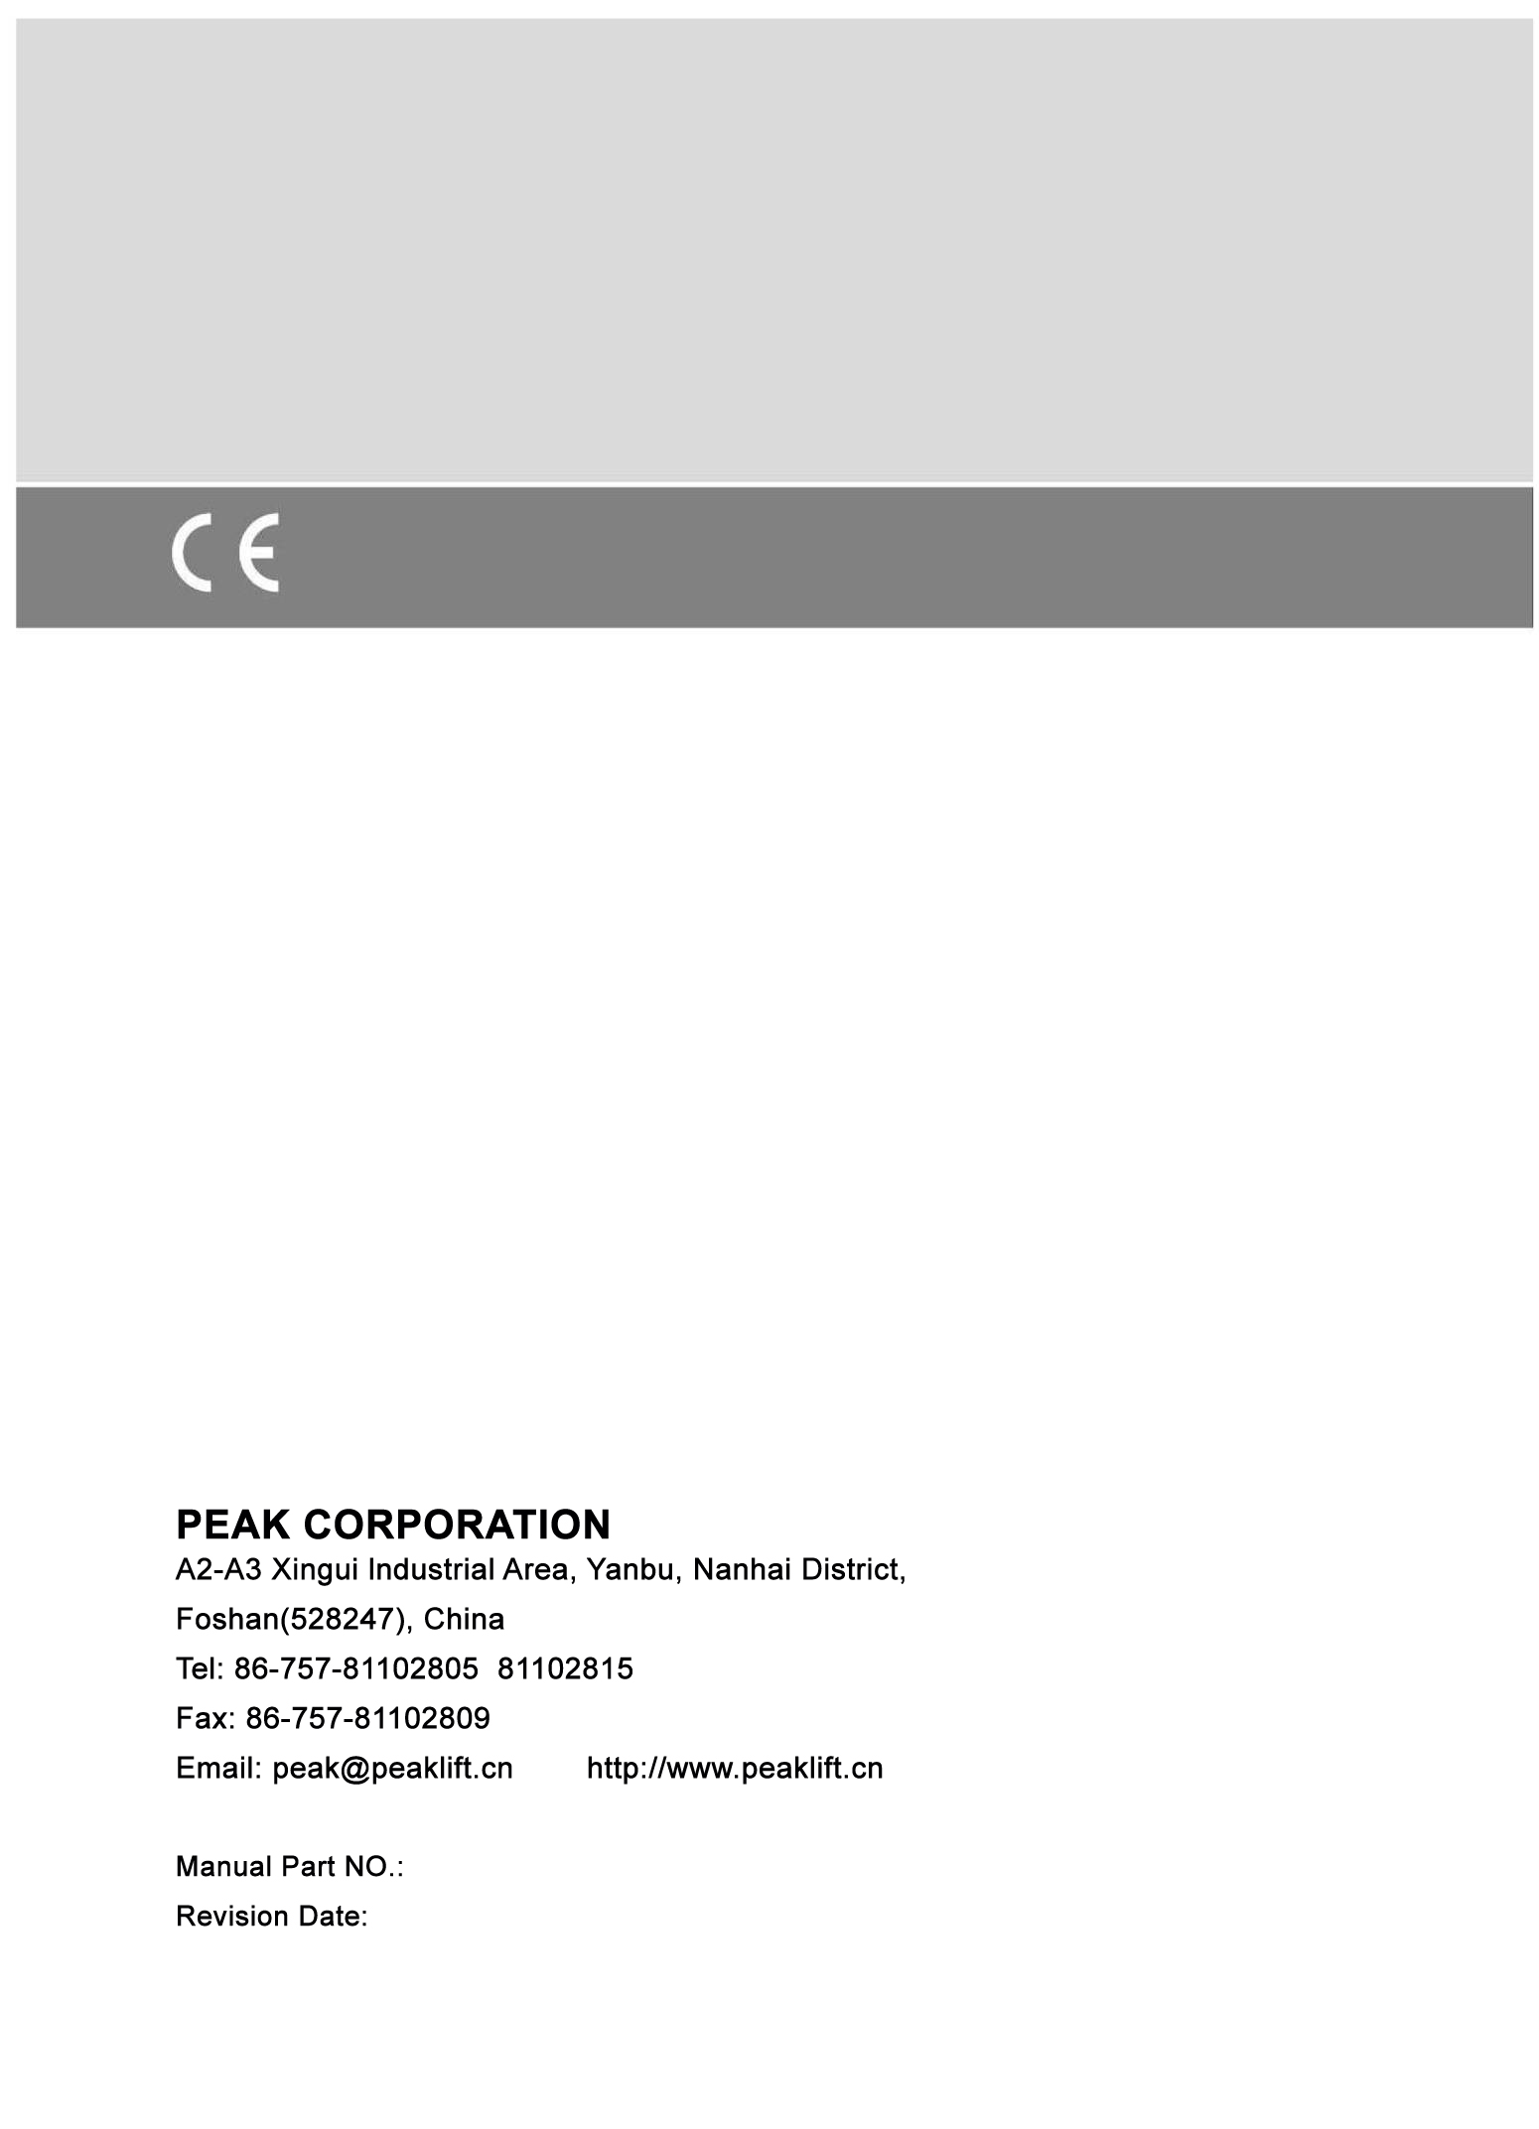
72125408
10/2018

